Display Options
Users can define how many concepts to display and whether or not to show hidden terms and/or synonyms. The display options are set in the Find Terms Options Dialog window (Figure 3.2), which can be accessed by clicking on the Options () button.

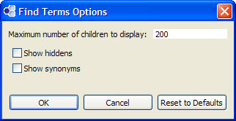
Figure 3. 1 Find Terms Options Dialog Box

Maximum to Display
The Maximum number of children to display is used when the system is retrieving the concepts to be displayed when returning the results in the results section of the Find Terms View. Once the maximum number is reached a message (Figure 3.3) will appear informing you that the query has reached the maximum defined and that continuing to retrieve all the concepts (“nodes”) in the list may affect performance. You will have the option to continue or to cancel the action.

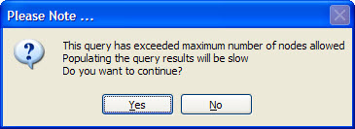
Figure 3. 2 Maximum Number Exceeded Message

Show Hiddens
In the metadata table, an attribute is set to determine whether or not a concept is active, inactive or hidden. If a concept is marked as hidden it will not appear in the list of terms. Selecting Show Hiddens will display those concepts marked to be hidden.

Show Synonyms
Some concepts may be flagged in the metadata table as a synonym of another concept. Selecting Show Synonyms will display both the original concept and the synonym in the Find Terms View.

