Search by Code
Some of the concepts have a standard code associated with them. This code can be used to search for a specific concept or a grouping of concepts.

Note: Although the steps below are for searching by LOINC code, they can be used for searching by any type of code. In step 4, replace LOINC with the coding system you will be using.

Search Using LOINC Code

- Click on the down arrow located in the qualifier field and select the one that is appropriate for your search.

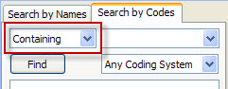
Figure 3. 1 Qualifier Drop Down List

- In the search box enter the code for the concept you are searching on.

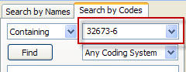
Figure 3. 2 Search Box

- Click on the down arrow located in the coding system selection field.

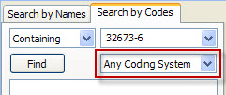
Figure 3. 3 Coding System Box

- Select LOINC from the drop down list.

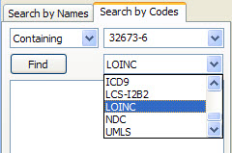
Figure 3. 4 Select Loinc

- Click on the Find button.

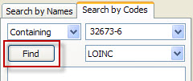
Figure 3. 5 Find Button

- The results will be displayed in the results section.

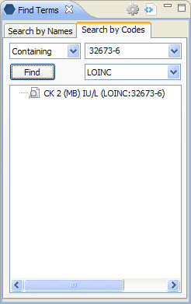
Figure 3. 6 Results for Search by Code

