Search by Name
The method of searching by the name is exactly what it sounds like; you can search for a concept by its name.

Search Using “Starting with”

- Click on the down arrow located in the first field (qualifier field).

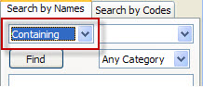
Figure 3. 1 Qualifier Drop Down List

- Select Starting with from the drop down list.

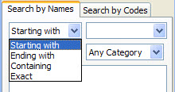
Figure 3. 2 Starting With Selection

- In the search box enter the text for the concept you are searching on.

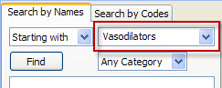
Figure 3. 3 Search Box (Starting with)

- To narrow your search to a particular category, click on the down arrow in the category selection box. Otherwise, accept the default of Any Category.

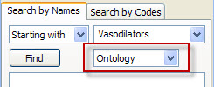
Figure 3. 4 Category Box

- Click on the Find button.

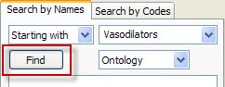
Figure 3. 5 Find Button

- The results will be displayed in the results section.

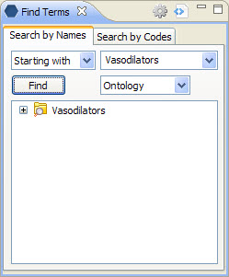
Figure 3. 6 Results for Search by Names

Search Using “Ending with”

- Click on the down arrow located in the Qualifier field (see Figure 3.4).
- Select Ending with from the drop down list.

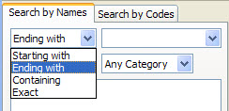
Figure 3. 7 Ending with Selection

- In the search box enter the text for the concept you are searching on.

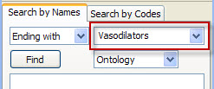
Figure 3. 8 Search Box (Ending with)

- To narrow your search to a particular category, click on the down arrow in the category selection box. Otherwise, accept the default of Any Category (see Figure 3.7).
- Click on the Find button. (see Figure 3.8)
- The results will be displayed in the results section.

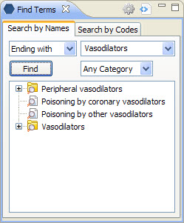
Figure 3. 9 Results for Search by Names (Ending with)

Search Using “Containing”

- Click on the down arrow located in the Qualifier field (see Figure 3.4).
- Select Containing from the drop down list.

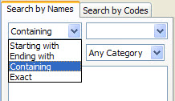
Figure 3. 10 Containing Selection

- In the search box enter the text for the concept you are searching on.

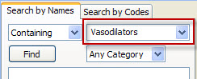
Figure 3. 11 Search Box (Containing)

- To narrow your search to a particular category, click on the down arrow in the category selection box. Otherwise, accept the default of Any Category (see Figure 3.7).
- Click on the Find button. (see Figure 3.8)
- The results will be displayed in the results section.

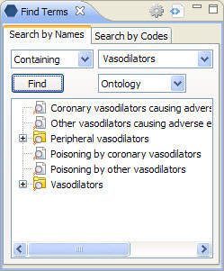
Figure 3. 12 Results for Search by Names (Containing)

Search Using “Exact”

- Click on the down arrow located in the Qualifier field (see Figure 3.4).
- Select Exact from the drop down list.

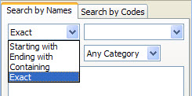
Figure 3. 13 Exact Selection

- In the search box enter the text for the concept you are searching on.

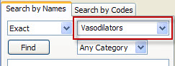
Figure 3. 14 Search Box (Exact)

- To narrow your search to a particular category, click on the down arrow in the category selection box. Otherwise, accept the default of Any Category (see Figure 3.7).
- Click on the Find button. (see Figure 3.8)
- The results will be displayed in the results section.

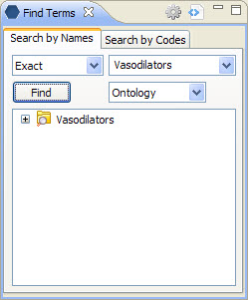
Figure 3. 15 Results for Search by Names (Exact)

