Add to Export Data View
The export data view is designed to compile the requested data and display the information in a graphical representation.

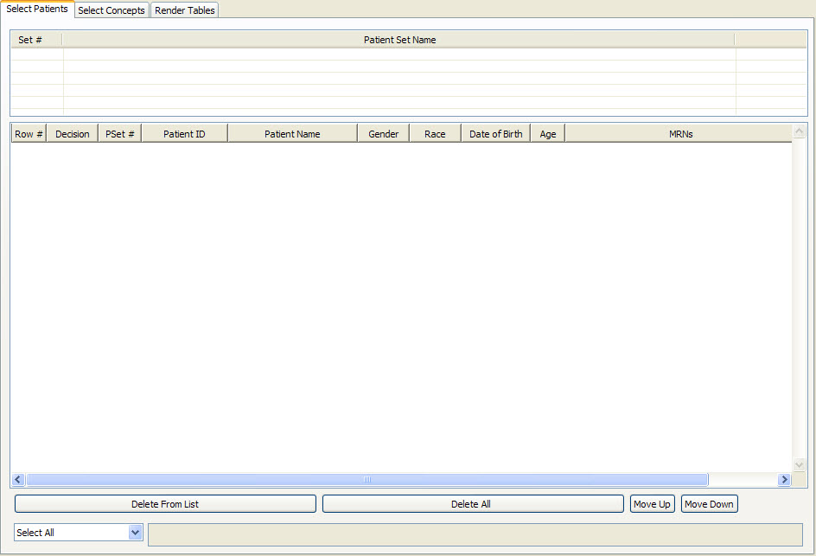
Figure 3. 1 Export Data View

Add Folder To Export Data View
- Highlight the folder () by clicking on the name of the folder.
- While holding the left mouse button down, drag the folder over to the Export Data View.
- Drop the folder into the concept list section of the Select Concepts tab.
- The folder will now display in the Export Data View.

Add Concept To Export Data View
- Highlight the concept () by clicking on the name of the concept.
- While holding the left mouse button down, drag the folder over to the Export Data View.
- Drop the concept into either the concept list section of the Select Concepts tab.
- The concept will now display in the Timeline View.

