Add to Query Tool View
A folder or individual concept can be added to the query tool view by simply dragging the item from Find Terms View and dropping it into one of the panels in the Query Tool View.

Add Folder To Query Tool View
- Highlight the folder () by clicking on the name of the folder.
- While holding the left mouse button down, drag the folder over to the Query Tool View.
- Drop the folder into the panel labeled Group 1.

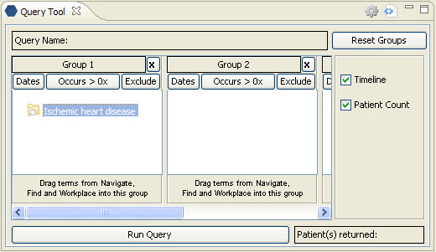
Figure 3. 1 Dropping Folder in Query Tool View

- The folder will now display in the panel for Group 1.


Figure 3. 2 Folder Added to Query Tool View

Add Concept To Query Tool View
- Highlight the concept () by clicking on the name of the folder.
- While holding the left mouse button down, drag the folder over to the Query Tool View.
- Drop the concept into the panel labeled Group 1.

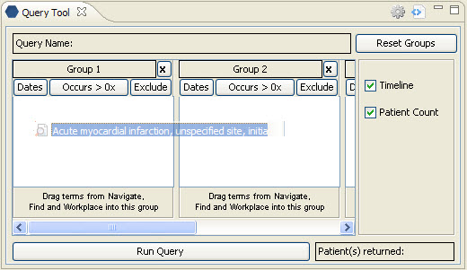
Figure 3. 3 Dropping Concept in Query Tool View

- The concept will now display in the panel for Group 1.

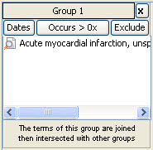
Figure 3. 4 Concept Added to Query Tool View

