Add to Workplace View
Information in the workplace is related to the most common concepts and queries that an individual uses and in essence becomes their personal workplace.

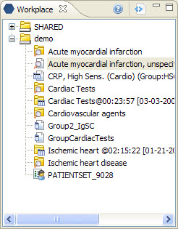
Figure 3. 1 Workplace View

Add Folder To Workplace View
- Highlight the folder () by clicking on the name of the folder.
- While holding the left mouse button down, drag the folder over to the Workplace View.
- Drop the folder into either your workplace folder or the shared folder
- The folder will now display in the Workplace View with the same name.

Add Concept To WorkpLACE View
- Highlight the concept () by clicking on the name of the concept.
- While holding the left mouse button down, drag the folder over to the Workplace View.
- Drop the concept into either your workplace folder or the shared folder
- The concept will now display in the Workplace View with the same name.

