i2b2 Navigate Terms View
The Navigate Terms View is designed to display the i2b2 vocabulary concepts that are maintained in the Ontology Management Cell of the i2b2 Hive. These concepts are used in many of the i2b2 views, such as Query Tool, Timeline and Export Data.

Introduction
This section describes the layout and contents of this view.

Layout of the Navigate Terms View
The Navigate Terms view displays the concepts listed in the metadata table. These concepts are grouped (categorized) with other similar items. These groupings are displayed in a hierarchal tree that can be expanded to view all the concepts in the associated category.

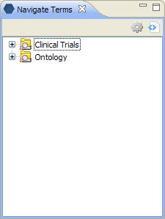
Figure 5. 1 Navigate Terms View

As stated above, the Navigate Terms View is hierarchical display of the concepts in the metadata table. There are three main branches or components of the tree that displays.

Table Name
The highest level is the name of the metadata table that stores the vocabulary. This level cannot be used when creating a query.

Folders
A folder () contains other folders and/or concepts. It can be expanded and collapsed by clicking on the plus or minus sign next to it. It can also be dragged to other views.

Concept
The concept () is the lowest level of the hierarchy. They cannot be expanded further.

