Display Options
Users can define how many concepts to display and whether or not to show hidden terms and/or synonyms. The display options are set in the Navigate Terms Options Dialog window (Figure 5.2), which can be accessed by clicking on the Options () button.

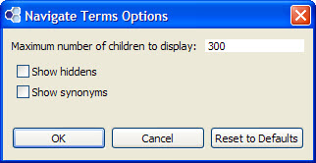
Figure 5. 1 Navigate Terms Options Dialog Box

Maximum to Display
The Maximum number of children to display is used when the system is retrieving the concepts to be displayed when expanding the folder in Navigate Terms View. Once the maximum number is reached a message (Figure 5.3) will appear informing you that you have reached the maximum defined and that continuing to retrieve all the concepts (“nodes”) in the list may affect performance. You will have the option to continue or to cancel the action.

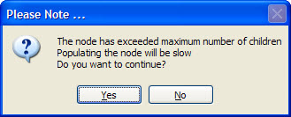
Figure 5. 2 Maximum Children Message

If you choose not to continue then “Over maximum number of child nodes” will display instead of the associated concepts.

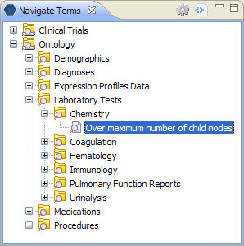
Figure 5. 3 Over Maximum Displayed in List

Show Hiddens
In the metadata table, an attribute is set to determine whether or not a concept is active, inactive or hidden. If a concept is marked as hidden it will not appear in the list of terms. Selecting Show Hiddens will display those concepts marked to be hidden.

Show Synonyms
Some concepts may be flagged in the metadata table as a synonym of another concept. Selecting Show Synonyms will display both the original concept and the synonym in the Navigate Terms View.

