Delete/Remove a Previous Query
Users can remove a previous query from the list by selecting Delete from the drop-down list.

- Using the right mouse button, click on the Previous Query to be deleted.
- A drop down list will open.

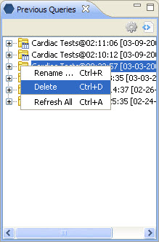
Figure 6. 1 Delete

- Select Delete from the list.

Warning: Once you click on Delete, the previous query will be removed. Therefore you need to make sure you want to remove it from the list.

