Rename a Previous Query
Users can rename a previous query from the list by selecting Rename from the drop-down list.

- Using the right mouse button, click on the Previous Query to be renamed.
- A drop down list will open.

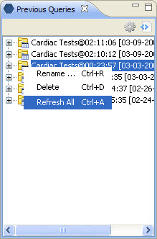
Figure 6. 1 Rename

- Select Rename from the list.

