Add to Export Data View
The export data view is designed to compile the requested data and display the information in a graphical representation.

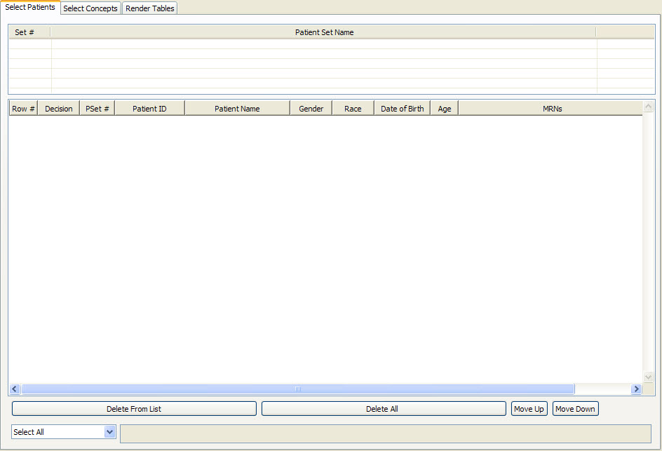
Figure 6. 1 Export Data View

Add Previous Query To Export Data View
- Highlight the previous query by clicking on the name of the query.
- While holding the left mouse button down, drag the previous query name to the Export Data View.
- Drop the previous query into concept list section of the Select Concepts tab.
- The concepts associated with the previous query will now appear in the Export Data View.

Add Patient List To Export Data View
- Click on the plus sign () next to the previous query that contains the patient set.
- Click on the plus sign () next to the results folder.
- Click on patient list ().
- While holding the left mouse button down, drag the patient list to the Export Data View.
- Drop the patient list into the patient list section of the Select Patients tab.
- The patient list section will now display all the patients in the patient list.

Add A Patient To Export Data View
- Click on the plus sign () next to the previous query that contains the patient set.
- Click on the plus sign () next to the results folder.
- Click on the plus sign () next to patient list.
- Click on the patient () to be copied.
- While holding the left mouse button down, drag the patient to the Export Data View.
- Drop the patient into the patient list section of the Select Patients tab.
- The patient will now appear in the list of patients.

