Add Group Template
Users can define a group of concepts that they frequently run and save them in their workplace view. This grouping of concepts is referred to as a group template.
A new query can be created using the group template by dragging the template from Workplace view to the Group Header.

- Find the group template you want to add (either in your folder or a shared folder).
- Click on the group template and drag it over to the Query Tool View.
- Drop the previous query into the panel labeled Group 1 (see figure 7.17)

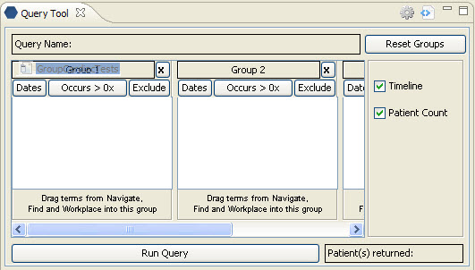
Figure 7. 1 Drag Group Templates

- The concept(s) associated with the group template will display.

