Date Constraint
Users can define a date range to be used when querying the database. This date range can be in any one of the following combinations:

SPECIFIED DATE RANGE: FROM AND TO DATES DEFINED
Only data with activity within the defined date range will be used.
Example:
Concept: Acute Myocardial Infarction
From date: 01/01/2001
To date: 12/31/2005
In this example, if a patient has a diagnosis of Acute Myocardial Infarction (MI) entered on the record from 01/01/2001 to 12/31/2005 then their data will be included. If the patient does have an MI diagnosis but it was entered prior to 01/01/2001 or after 12/31/2005 then their information will not be included.

SPECIFIC START DATE: ONLY THE FROM DATE IS DEFINED
Data from the defined start date to the latest date available. No end date defined.
Example:
Concept: Acute Myocardial Infarction
From date: 01/01/2001
To date:
In this example, if a patient has a diagnosis of Acute Myocardial Infarction (MI) entered on the record any time on or after 01/01/2001 will be included. If the diagnosis was entered prior to 01/01/2001 then the data will not be included.

SPECIFIC END DATE: ONLY THE TO DATE IS DEFINED
All data up until the defined end date. No start date defined.
Example:
Concept: Acute Myocardial Infarction
From date:
To date: 12/31/2005
In this example, if a patient has a diagnosis of Acute Myocardial Infarction (MI) entered on the record prior to and including 12/31/2005 then their data will be included. If the diagnosis was entered after 12/31/2005 then it will not be included.

SETTING THE DATE CONSTRAINT (FROM/TO DATE RANGE)
- Highlight the concept by clicking on it in the panel.
- Click on the Dates button located in the panel under the Group Name.
- A new window will open (Figure 7.19).

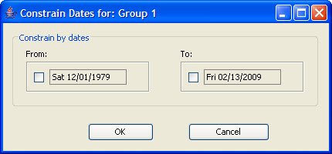
Figure 7. 1 Date Constraint Window

- Click the check box next to the date in the From box.
- Highlight the default date and enter the date you want to use as your starting date (Figure 7.20).

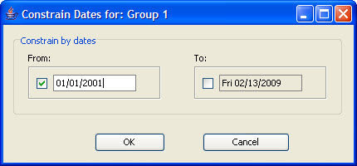
Figure 7. 2 Date Constraint (From Field)

- Click the check box next to the date in the To box.
- Highlight the default date and enter the date you want to use as your ending date (Figure 7.21).

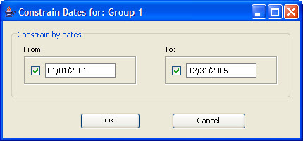
Figure 7. 3 Date Constraint (From and To Fields)

- Click on the OK button.
- Dates will now be underlined to indicate a date constraint has been set (Figure 7.22).

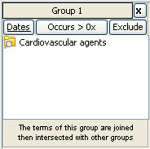
Figure 7. 4 Date Constraint Set

SETTING THE DATE CONSTRAINT (FROM DATE ONLY)
- Highlight the concept by clicking on it in the panel.
- Click on the Dates button located in the panel under the Group Name.
- A new window will open (see Figure 7.19).
- Click the check box next to the date in the From box.
- Highlight the default date and enter the date you want to use as your starting date (see Figure 7.20).
- Click on the OK button.
- Dates will now be underlined to indicate a date constraint has been set (see Figure 7.22).

SETTING THE DATE CONSTRAINT (TO DATE ONLY)
- Highlight the concept by clicking on it in the panel.
- Click on the Dates button located in the panel under the Group Name.
- A new window will open (see Figure 7.19).
- Click the check box next to the date in the To box.
- Highlight the default date and enter the date you want to use as your ending date (Figure 7.23).

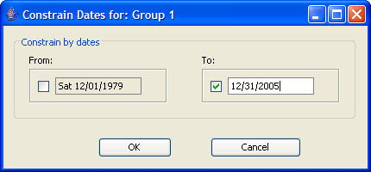
Figure 7. 5 Date Constraint (To Field)

- Click on the OK button.
- Dates will now be underlined to indicate a date constraint has been set (see Figure 7.22).

