Value Constraint
As stated earlier, not all concepts have values. For those concepts that do have values there are different types of values that may be associated with it.

Flag Value
Flags are defined in the source system when the value is entered. The following are some examples that can be found in the i2b2 Demo database.
- High
- Low
- Abnormal

Setting the Value Constraint (Flag)
- Right click on the concept listed in the panel.
- A list box will open.
- Select Set Value from the list (Figure 7.24).

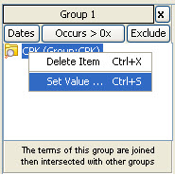
Figure 7. 1 Set Value List

- A new window will open (Figure 7.25).

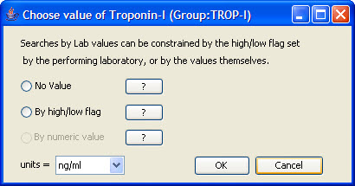
Figure 7. 2 Value Constraint Window (Flag)

- Click the radial dial next to By high/low flag.
- A new field with a drop down selection box will appear (Figure 7.26).

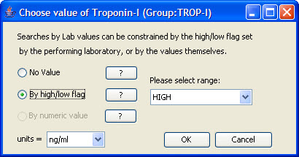
Figure 7. 3 Value Constraint (Flag)

- Click on the arrow to change the selection or accept the default.
- Click on the OK button.
- The constraint value entered will now appear next to the concept in the panel (Figure 7.27).

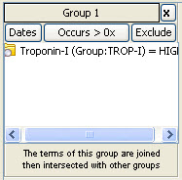
Figure 7. 4 Value Constraint Set (Flag)

Note: Depending on the available space, you may need to use the horizontal scroll bar at the bottom of the panel to see the entire value constraint.

Text Value
The text is defined in the source system when the value is entered. The following are some examples that can be found in the i2b2 Demo database.
- Test Not Performed
- Borderline
- Positive

Setting the Value Constraint (Text)
- Right click on the concept listed in the panel.
- A list box will open.
- Select Set Value from the list (see Figure 7.24).
- A new window will open (Figure 7.28).

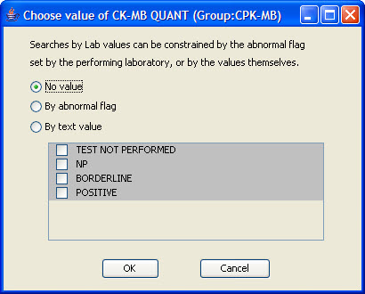
Figure 7. 5 Value Constraint Window (Text)

- Click the radial dial next to By text value.
- The text value options will now become available to select. Click on the box next to the values you want to include (Figure 7.29).

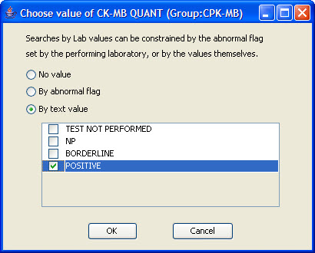
Figure 7. 6 Value Constraint (Text)

- Click on the OK button.
- The constraint value entered will now appear next to the concept in the panel.

Note: Depending on the available space, you may need to use the horizontal scroll bar at the bottom of the panel to see the entire value constraint.

Numeric Value
The numeric value is defined in the source system when the result is entered. The following are some example formats that can be found in the i2b2 Demo database.
- 200
- 1.3

Unlike flag and text values, numeric values use operators, such as greater than or less than when setting the constraints. The following is a listing of operators currently in use.

Operator | Description/Use
Less Than (<) | Any value less than the number entered.
Less Than or Equal To (<=) | Any value less than or equal to the number entered (inclusive).
Equal To (=) | An exact match to the number entered.
Between | Any value in the range of numbers entered.
Greater Than (>) | Any value greater than the number entered.
Greater Than or Equal To (>=) | Any value greater than or equal to the number entered (inclusive).

Setting the Value Constraint (Numeric)
- Right click on the concept listed in the panel.
- A list box will open.
- Select Set Value from the list (see Figure 7.24).
- A new window will open (Figure 7.30).

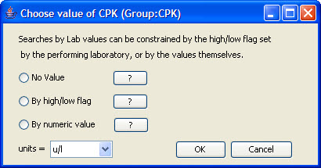
Figure 7. 7 Value Constraint Window (Numeric)

- Click the radial dial next to By numeric value.
- Two new fields, one with a drop down selection box will appear (Figure 7.31).

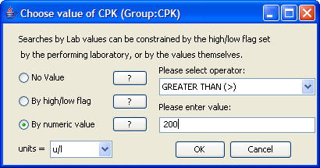
Figure 7. 8 Value Constraint (Numeric)

- Click on the Drop-down arrow to change the operator or accept the default.
- Enter a numerical value at the Please enter value field.
- Click on the OK button.
- The constraint value entered will now appear next to the concept in the panel (Figure 7.32).

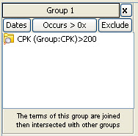
Figure 7. 9 Value Constraint Set (Numeric)

