Operators
There are two operators, known as SQL Logical Operators, which are necessary when running a query that has more than one concept. These operators provide a way to specify exactly what you want to retrieve. The operators are the ‘AND’ and ‘OR’ operators.
The query tool knows which operator to use based on the panels used when defining the query. It is important to verify you are setting up your query correctly as each operator will return different results.

AND Operator
The AND operator returns a record if both the first condition and the second conditions are true.
The query tool uses the AND operator when concepts are listed in different panels.
Example:
WHAT: Return only those patients who have Acute Myocardial Infarction AND Angina Pectoris.
HOW: In the query tool add the concept Acute Myocardial Infarction to Group 1 and then add the concept Angina Pectoris to Group 2 (Figure 7.6).
RESULT: The population is limited by requiring the patients fulfill both requirements.

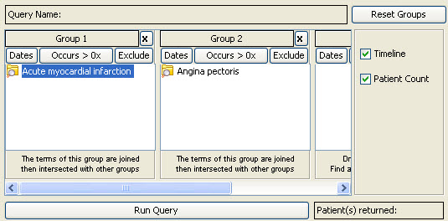
Figure 7. 1 ‘AND’ Operator

OR Operator
The OR operator returns a record if either the first condition or the second conditions is true.
The query tool uses the OR operator when concepts are listed in the same panel.
Example:
WHAT: Return any patients who have Acute Myocardial Infarction or Angina Pectoris associated to them.
HOW: In the query tool you add both concepts, Acute Myocardial Infarction and Angina Pectoris, to Group 1 (Figure 7.7).
RESULT: The population is broadened to include all patients who fit either on of those criteria.

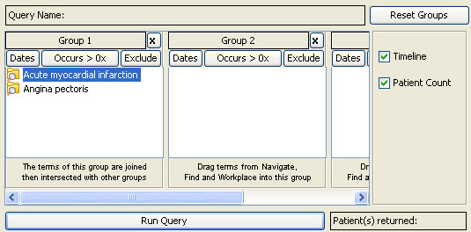
Figure 7. 2 ‘OR’ Operator

