i2b2 Query Tool View
The query tool view is designed to simplify the process of retrieving information from the database associated to the i2b2 Workbench.

Introduction
Describes the layout and contents of this view

Layout of the Query Tool View
The query tool view (figure 7.1) is used to define and run a select query, which retrieves information from the database associated to the i2b2 Workbench.

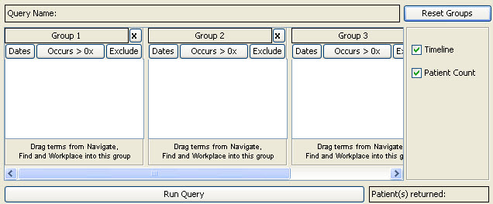
Figure 7. 1 Query Tool View

The query tool view can be broken down into several sections which are defined below.

Query Name
A name will be assigned to a query at the time the query is run. This name will display in the Query Name field (Figure 7.2).
The only time a query name will appear prior to running the query is when you drag a previous query from either Previous Query View or Workplace View and drop it into the Query Name field.

Figure 7. 2 Query Name

Panel
A panel is the section of the query tool view that contains information about a group of concepts. The panel can be broken down into the following sections (Figure 7.3).

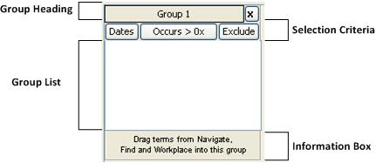
Figure 7. 3 Panel

Group Heading
The heading is a label to easily identify the collection of concepts. Each heading will contain “Group” followed by a sequential number.
Example: Group 1, Group 2, Group 3, etc.

Selection Criteria
This area of the panel is used to define date selections and other constraints.

Group List
This section contains the concepts that will be used during the process of querying the database.

Information Box
The content in the information box will change depending on whether or not a concept is listed in the group.
Currently there are two different messages that will appear:
  - No Concepts
Drag terms from Navigate, Find and Workplace into this group

  - Concept(s) listed
The terms of this group are joined then intersected with other groups

Analysis Selection Box
Select what to return when running the query. Currently there are two options (Figure 7.4).

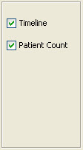
Figure 7. 4 Selection Box

Timeline
A check in the box next to Timeline means the data will be displayed in the timeline view. This option will return patient information as well as information for the concepts defined in the query.

Patient Count
A check in the box next to Patient Count will return a number indicating the number of patients in the database that meet the search criteria defined.

Patients Returned Box
In the bottom left corner of the query view is the Patients Returned box (Figure 7.5). Once a query has been run, the number of patients meeting the search criteria will appear in this box. This is a display only box.

Figure 7. 5 Patients Returned Box

