Analysis Selection
Users can select one or both of the following analysis selections.

Timeline
Two things will occur when this option is selected; (1) Information will appear in the timeline view and (2) and in previous query view the previous query will contain a list of all the patients who met the criteria defined when creating the query.

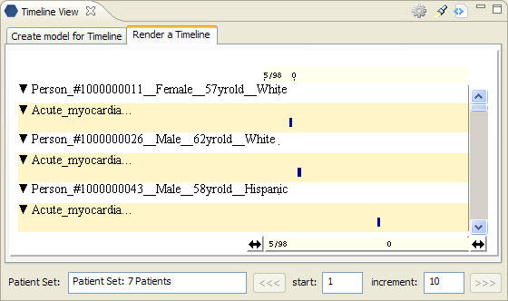
Figure 7. 1 Timeline View

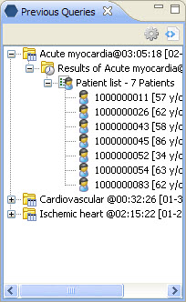
Figure 7. 2 Previous Query – Patient List

Patient Count
This option will return the number of patients who met the criteria defined in the creation of the query.

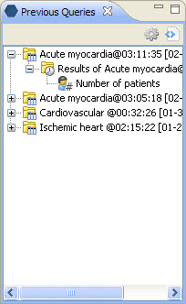
Figure 7. 3 Previous Query – Patient Count

Note: The number is displayed in the tool tip, which can be seen by hovering over Number of Patients.

