Saving a Query
There are two types of saved queries; (1) Previous Query and (2) Query Definition. How the query is saved will determine the type.
From a user standpoint there is very little difference in a Previous Query and a Query Definition. The difference is behind the scene. Basically, the XML for the previous query contains a pointer to where the query is stored in the database. The XML for the query definition contains all the information about the query.

Previous Query
A previous query () is created automatically when the query is run from the Query Tool. The query is stored and displayed in the Previous Query View.

Note: Previous queries can also be seen in Workplace View if the user copied it to their workplace or shared folder in workplace view.

- Run a query.
- Go to the Previous Query View.
- Query that you just ran will now appear in the list of previous queries (Figure 7.37).

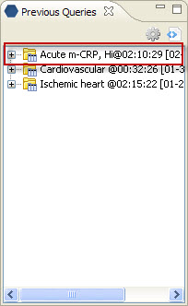
Figure 7. 1 Previous Query Listed

Query Definition
A query definition () is created when a user drags the query name from the query tool view to the workplace view.

- Click on the Query Name in the query tool view.
- While holding the left mouse button down, drag the query name to the Workplace view.
- Drop the query name into either your workplace folder or the shared folder.
- The query will now appear in the workplace with the same name plus a unique identifier that is randomly assigned (Figure 7.38)

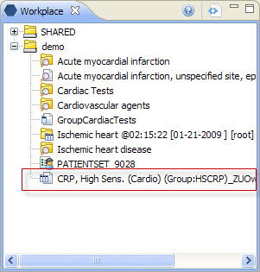
Figure 7. 2 Query Definition in Workplace

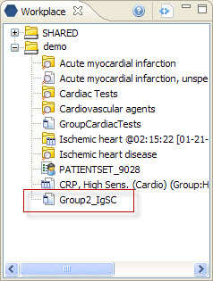
Figure 7. 3 Group Template in Workplace

