Layout of the Options Tab

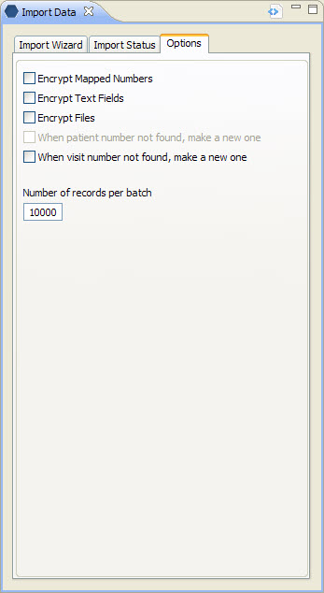
Figure 4. 1 Options Tab

Encryption Fields
In order to comply with confidentiality standards, patient identifying data must be encrypted. There are three areas that can be encrypted; (1) Mapped Numbers, (2) Text Fields and (3) Files.

Encrypt Mapped Numbers
Mapped numbers are the number fields that link information in one table to another table. Some examples are the patient_num field and the encounter_num field.

Encrypt Text Fields
Text Fields that are encrypted are the blob data type. An example of what may be in a text field is a patient note or report for a radiology exam.

Encrypt Files

Create Patient and Visit Number Fields
When the data being loaded does not have an existing patient and/or encounter number, users can choose to have the system randomly generate one.

When patient number not found, make a new one
A check mark at this field means the system will randomly generate an alphanumeric ID for the patient_id and assign the patient_source for the new ID.

When visit number not found, make a new one
A check mark at this field means the system will randomly generate an alphanumeric ID for the encounter_id and assign the encounter_source for the new ID.

Number of records per batch
This field is used to specify the number of records to be uploaded in a single batch. If the number of records in a file exceeds the number of records defined per batch, then the system will continue to generate additional batches until all the records are uploaded.

Example:
Number of records per batch: 10000
Number of records in the import file: 35000

In this example, the system will create a total of 4 batches. The first three batches will contain 10000 records and the fourth one will contain the remaining 5000 records.

