Layout of the Import Wizard Tab
The Import Wizard tab is where the data to be imported is mapped, the data is verified and the process of importing is started. The view is comprised of three sections; (1) Choose data, (2) Verify Data and (3) Upload data.

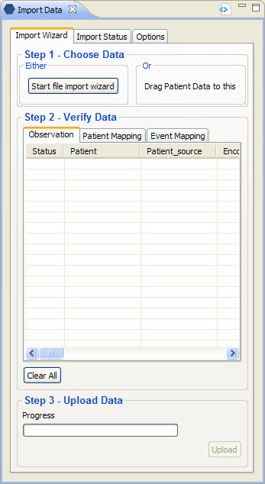
Figure 4. 1 Import Wizard Tab

Choose Data Section
The first step in the import process is to identify and map the data to be imported. Users can do this by either using the import wizard or by dragging a set of patient data from the Pulmonary view.

Note: At the time the only view that can be used to drag patient data from is the pulmonary view.

Verify Data Section
The second step is to verify the data being imported is mapped correctly. In this section there are three tabs; (1) Observation, (2) Patient Mapping, and (3) Event Mapping. The type of data being uploaded will determine which tab will be used to verify the data.

Observation Tab
The Observation tab displays the observations to be uploaded. The columns that appear are dependent on the data that is being uploaded.

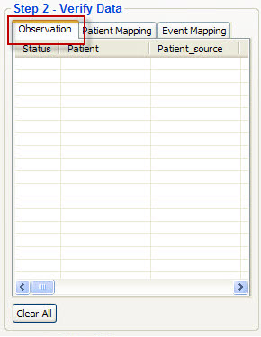
Figure 4. 2 Verify Observations

Patient Mapping Tab
The Patient Mapping tab displays the patients to be uploaded. The columns that appear are dependent on the data that is being uploaded.

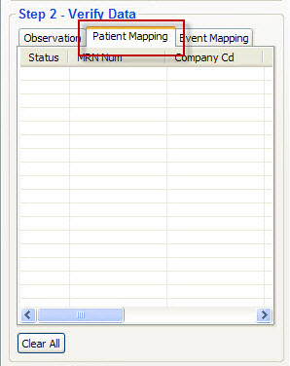
Figure 4. 3 Verify Patients

Event Mapping Tab
The Event Mapping tab displays the events to be uploaded. The columns that appear are dependent on the data that is being uploaded.

Note: Events are also known as encounters.

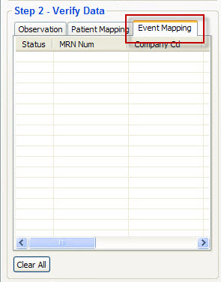
Figure 4. 4 Verify Events

Upload Data Section
The third and final step in the upload process is to start it. This is done by clicking on the upload button in the Upload Data section. A progress bar is displayed and will be activated once the upload process has begun.

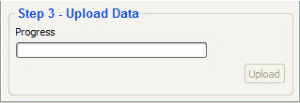
Figure 4. 5 Upload Data

