Import Data
There are basically three steps to importing data into the i2b2 database. (1) Choose the data, (2) verify the data and (3) start the import.
The Import Data View provides a wizard to assist users in choosing and mapping the data to the correct fields in the i2b2 database.

Choose Data

Import Wizard
The import wizard is designed to take you through each step of the import process.

- Click on the Start File Import Wizard button located in the Choose Data section.

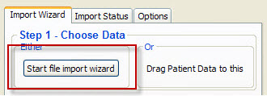
Figure 4. 1 Start File Import Wizard

- The import wizard window will open to the first page.

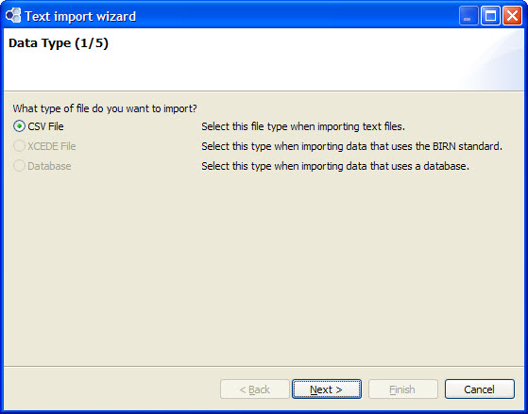
Figure 4. 2 Import Wizard Page 1

- Select the type of file you are importing.
- Click on the Next button located at the bottom of the window.

Figure 4. 3 Next Button

- A dialog box will open.

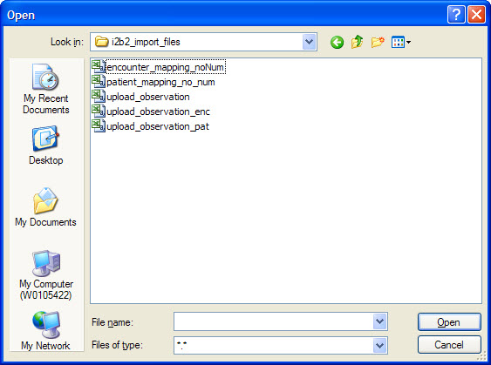
Figure 4. 4 Select File Dialog Box

- Select the file to be imported.
- Click on the Open button.

Figure 4. 5 Open Button

- The second page of the wizard will now open.

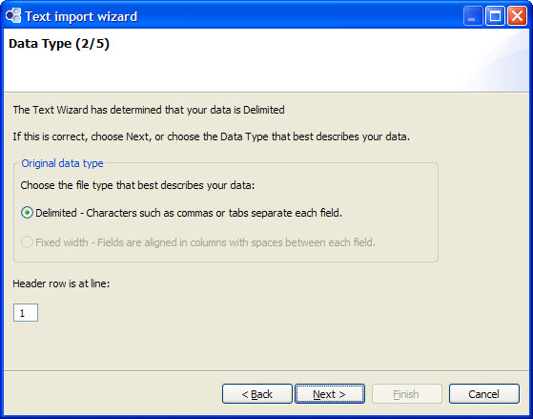
Figure 4. 6 Import Wizard Page 2

- Select the type of file being imported.

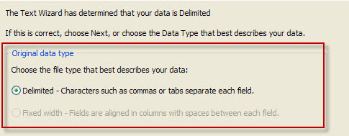
Figure 4. 7 File Type Selection

- Enter the correct line number at the Header row is at line prompt.

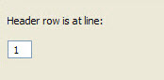
Figure 4. 8 Header Row Selection

- Click on the Next button located at the bottom of the window.
- The third page of the wizard will be displayed.

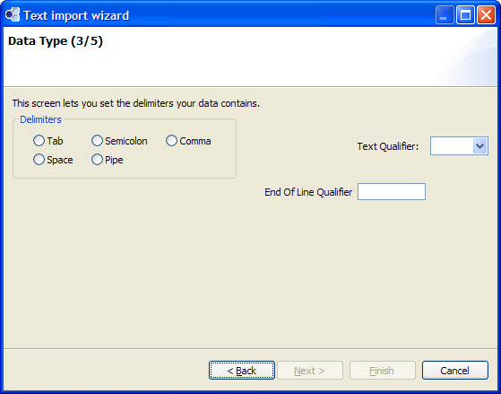
Figure 4. 9 Import Wizard Page 3

- Check off the appropriate delimiter.
- If appropriate, enter a qualifier at the Text Qualifier field.
- If appropriate, enter a qualifier at the End of Line Qualifier.
- Click on the Next button.
- The fourth page of the wizard will be displayed.

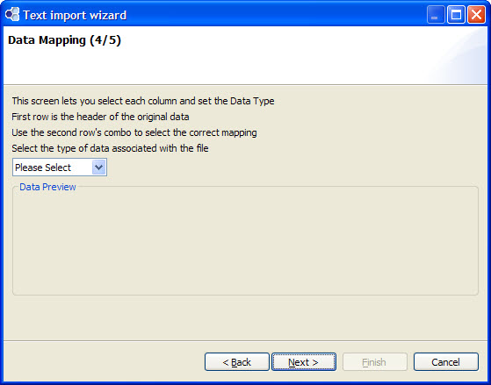
Figure 4. 10 Import Wizard Page 4

- Select the type of data associated with the file.

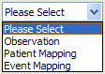
Figure 4. 11 Type of Data Selection

- Verify the data in the columns matches the column heading (row 1).
- If the data does not match click on the column heading in row 2.
- A drop down list will display.

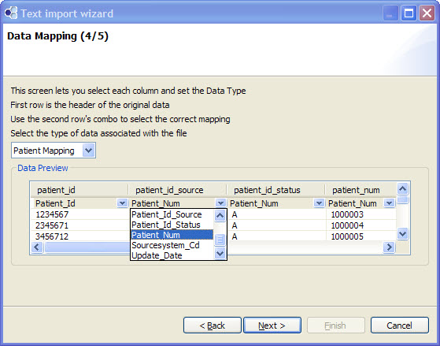
Figure 4. 12 Mapping Selections

- Select the appropriate column heading.
- Scroll down through the records and verify the data for each row is displayed in the appropriate columns.

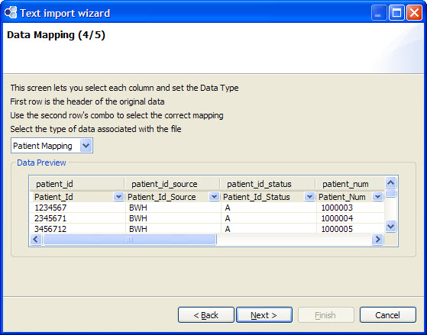
Figure 4. 13 Verify Data Columns

- Click on the Next button.
- The fifth page of the wizard will be displayed.

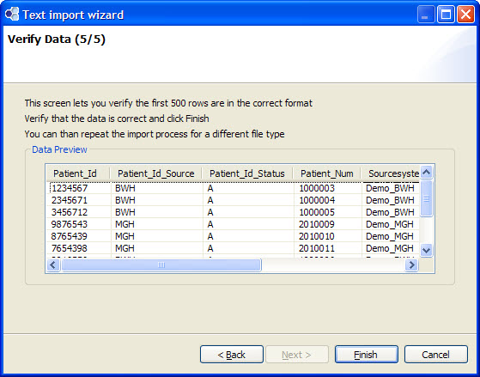
Figure 4. 14 Import Wizard Page 5

- Scroll through the records to verify the data for each row is displayed in the appropriate columns.
  - If the data is incorrect, click on the Cancel button and update the file with the appropriate delimiters.
  - If the data is correct, click on the Finish button.
- Once you have finished mapping the data with the import wizard the system will return you to the Import Data view where all the records in the file will appear in the Verify Data section.

Verify Data
The second step in the import process is to verify the data being imported is correct. Once you have finished the wizard, the data in your file will now appear under the appropriate tab in the Verify Data Section. Scroll through the data to verify everything appears correctly.
If an error is found you will need to click on the Clear All button, which will clear out all the records listed on the active tab. The next step will be to fix the error in the import file and then begin the import process again.

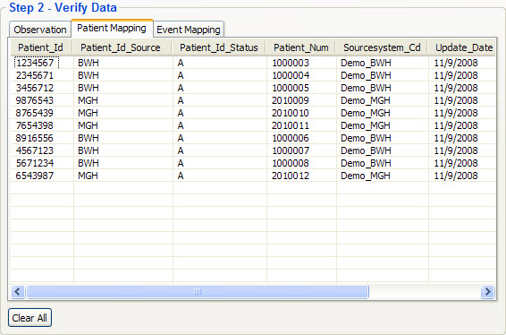
Figure 4. 15 Verify Data Section

Upload Data
Click on the Upload button located in the bottom right corner of the Import Data view. The progress bar will update to show the progress. Once the import process has been completed, the status bar will remain green and say finished.

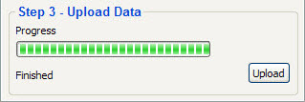
Figure 4. 16 Upload Data Progress

