Cluster Rows ( )
Cluster Rows performs a hierarchical clustering of the rows of the table based on the values in the selected columns. The distances between rows can be calculated using a variety of distance functions available in the CERN colt package. The default is Euclidean distance. The distance calculation between clusters can be set to Average (the averages of the rows distances between the cluster), Single-link (the least row distance), or Complete-link (the greatest row distance). The cluster button starts the clustering process.
The hierarchical cluster is displayed as a dendogram. Dragging out an area over the dendogram selects all rows in the table represented by the branches of the tree in the selected area.

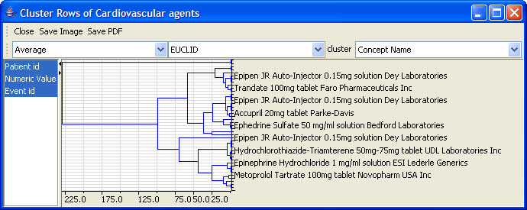
Figure 2.64 | Cluster Rows

