Cluto Cluster ( )
CLUTO is a 3rd party software package for clustering low- and high-dimensional datasets and for analyzing characteristics of the various clusters.

Algorithms
CLUTO provides three different classes of clustering algorithms that operate either directly in the object's feature space or in the object's similarity space. These algorithms are based on the partitional, agglomerative, and graph-partitioning paradigms.
A key feature in most of CLUTO's clustering algorithms is that they treat the clustering problem as an optimization process which seeks to maximize or minimize a particular clustering criterion function defined either globally or locally over the entire clustering solution space.

Criterion Functions
CLUTO provides a total of seven different criterion functions that can be used to drive both partitional and agglomerative clustering algorithms. Most of these criterion functions have been shown to produce high quality clustering solutions in high dimensional datasets, especially those arising in document clustering.

Multiple similarity/distance functions:
- Euclidean distance
- Cosine
- Correlation coefficient
- Extended Jaccard
- User-defined

Traditional agglomerative merging schemes:
- Single-link
- Complete-link
- UPGMA

Graph-Partioning-based clustering algorithms
Furthermore, CLUTO provides graph-partitioning-based clustering algorithms that are well-suited for finding clusters that form contiguous regions that span different dimensions of the underlying feature space

Additional Features
Multiple methods for effectively summarizing the clusters: most descriptive and discriminating dimensions, cliques, and frequent itemsets.
Can scale to very large datasets containing; hundreds of thousands of objects and tens of thousands of dimensions.

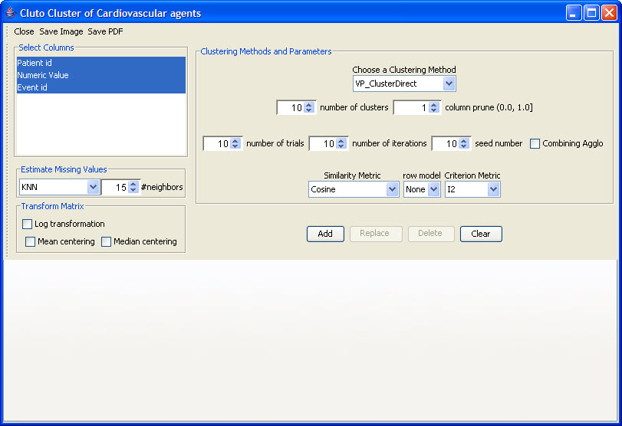
Figure 2.65 | Cluto Cluster

