Compare Columns ( )
Shows a line graph of the values of each selected column, superimposed using a common scale.
This might be a useful view of the table if successive rows in the table represent a time series of values

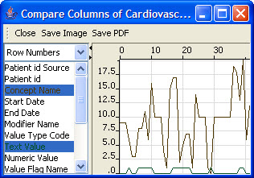
Figure 2.66 | Compare Columns

Compare Rows (Parallel Coordinate) ( )
This view displays the values of each row of a table as a line graph across a set of vertical axes which represent the columns of the table. Each vertical axis line represents one column from the table and each value from that column to map to the line by its relative distance between the minimum and maximum value for that column.
The user may select rows from the table by pressing the mouse button over a vertical axis and dragging vertically to select a region of values in that column.
The Selection of columns to operate on is controlled by selecting the diamond shape for the column at top the graph. The selection status of the column is indicated by whether the diamond-shape if filled. The anchor selection is drawn in black. Clicking on a diamond will select that column, a Double-Click selects only that column, and a Control-Click toggles the selected status of the column.

The Toolbar buttons operate as follows:
- Show All causes all columns to be displayed.
- Hide will hide the currently selected columns from view.
- Group will set the display range the same on the currently selected columns.
- Normalize will set the display range independently for each selected column.

The Radio buttons control which rows are displayed:
- All Rows Display all rows from the table.
- Selected Rows Tracks the selection and display those rows from the table.
- Current Rows Locks the display on the current selection.
The color gradient of the graph lines can be set to a column by double-clicking the diamond shape for the column at top the graph.
The columns may be reordered by dragging the diamond shape above a column to the left or right.
The mapping order of a column may be inverted by clicking on the triangle below the column.

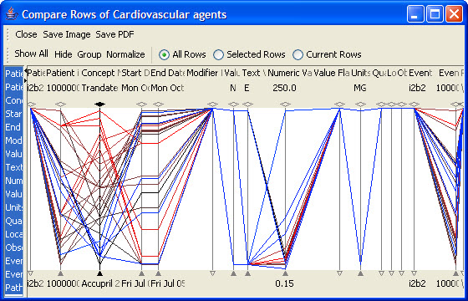
Figure 2.67 | Compare Rows

