Select by Regular Expression Mapping ( )
Search allows for the search of matching values in a column. Enter a regular expression for the desired column, and then press the Set operation to specify how to apply the matches to the selection of rows. Example:

Match values that contain 'nitroglycerin' | *.nitroglycerin.*
Match values that start with 'nitroglycerin' | nitroglycerin.*
Match values that end with 'nitroglycerin' | *. nitroglycerin

Selection Set Operation Choice:
Replace ( ) | Replace the previous selection with new selection
Union ( ) | Union previous selection with the new selection
Intersect ( ) | Intersect previous selection with the new selection
Diff ( ) | Delete the new selection from the previous selection
XOR ( ) | Exclusive OR of previous selection with new selection
For more information on regular expressions:
http://java.sun.com/docs/books/tutorial/extra/regex/index.html
http://java.sun.com/j2se/1.4.2/docs/api/java/util/regex/Pattern.html

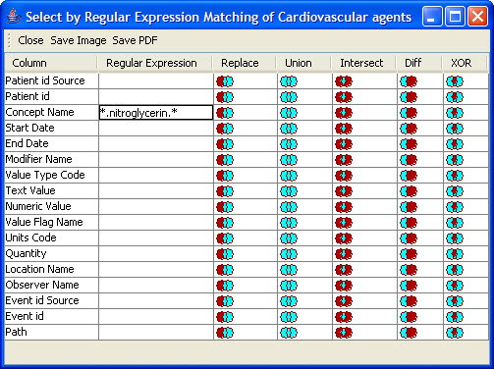
Figure 2.81 | Select Regular Expression Mapping

