Row Graphs ( )
This displays a table that has a row for each distinct value of the selected column. The table displays the value in the first column and a graph of row values in the second column. Double-Clicking on the graph, will open a Compare Rows view.
The column to display is selected in the Graph Column box.
The height in pixels for each graph can be set in the Graph Height box. The width of the graph can be adjusted by dragging the edge of the column header.
The look of the graph is set using the Graph Prototype. This is a Compare Rows view that serves as a model for all of the graphs displayed.

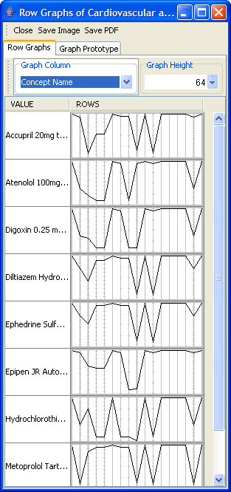
Figure 2.76 | Row Graphs

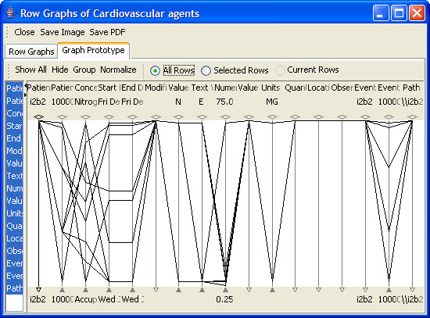
Figure 2.77 | Graph Prototype

