Span Plot ( )
This provides a pairwise scatter plot of any three columns in the table. Two columns represent the starting and ending values of a span along the X axis, while the third column provides the mapping to the Y axis. The columns are selected by choosing from the Xs, Xe, and Y lists of column names, and the span plot is displayed when the Plot button is pressed.
The user may select rows from the table by pressing the mouse button over a scatterplot and dragging out a rectangular region.

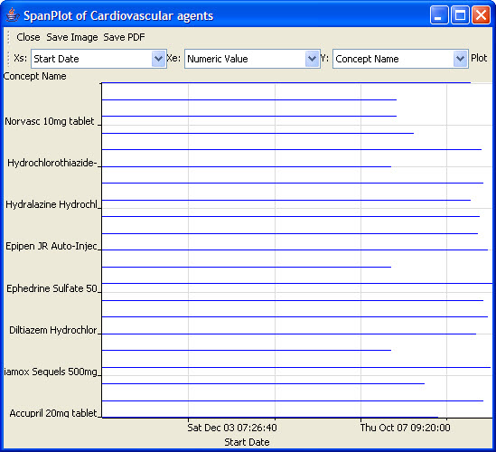
Figure 2.80 | Span Plot

