Histograms ( )
This view presents a histogram for each column in the table. A histogram shows how many rows of the table have values that fall in each sub range between the minimum and maximum values for a column. Changing the width of the window will cause each histogram to be recomputed.
The toolbar has a button with an iconic histogram for each column in the table. Selecting a button on the toolbar displays an interactive histogram.
The user may select rows from the table by pressing the mouse button over a histogram and dragging left or right to select a range of values from the column. Rows from the table that correspond to that range of values are selected.
The highlighted portion of each bar shows how many rows with that value are selected.

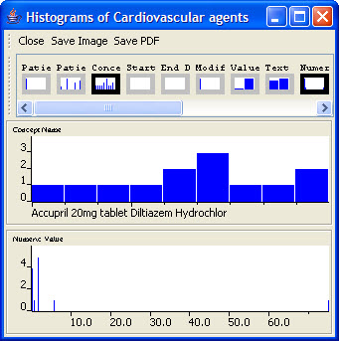
Figure 2.71 | Histograms

