Pie Chart ( )
This view presents a pie chart to represent the histogram. If multiple columns are included in the histogram, there will be a ring for each column.

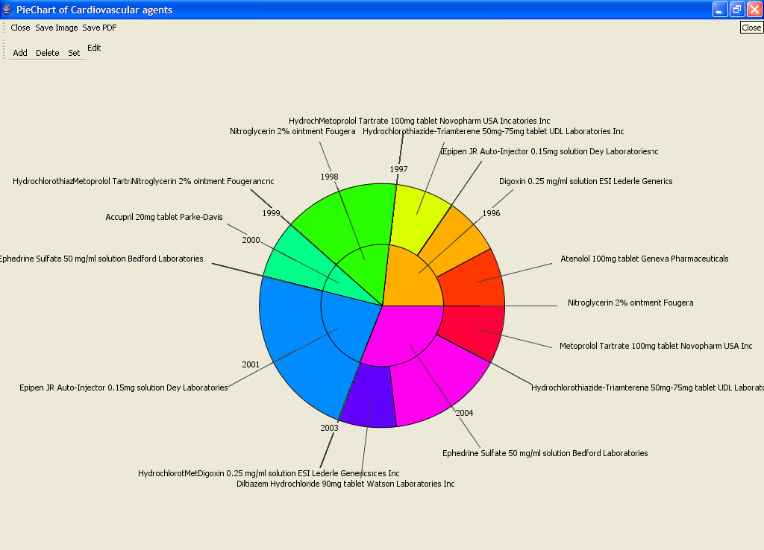
Figure 2.74 | Pie Chart

