Plot 3D ( )
Scatter Plots in 3D
Provides a 3D scatter plot of values from three columns of a table.
The Java3D component provides high performance 3D viewing.
The Plot 3D component is an all software version that provides similar functionality for those that don't have Java3D.
A control button sets interaction to either navigation or selection. While navigating the left mouse button rotates, the center mouse (or Alt Left Mouse Button) zooms in or out, and the right mouse button translates the view up, down, left or right. While selecting, press the mouse over the view and drag out a region to select rows corresponding to the values in the selected region.

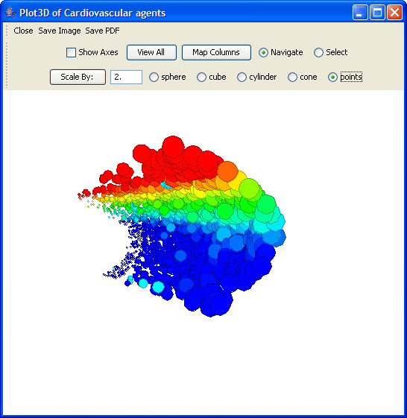
Figure 2.75 | Plot 3D

