Scatter Plot ( )
This provides a pairwise scatter plot of any two columns in the table. The columns are selected by choosing from the X and Y lists of column names, and the scatter plot is displayed when the Plot button is pressed.
The user may select rows from the table by pressing the mouse button over a scatterplot and dragging out a rectangular region.

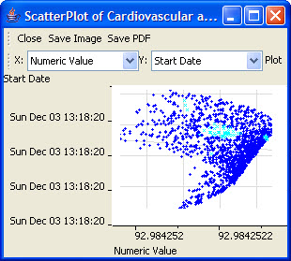
Figure 2.78 | Scatter Plot

