Add to Timeline View
The timeline view displays the information in a graphical representation of a chronological sequence of events.

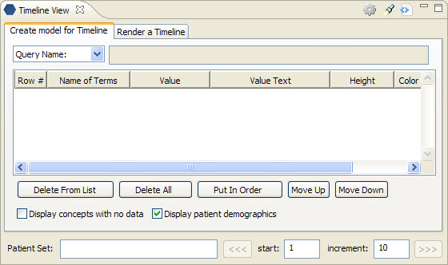
Figure 5. 1 TimelineView

Add Folder To Timeline View
- Highlight the folder () by clicking on the name of the folder.
- While holding the left mouse button down, drag the folder over to the Timeline View.
- Drop the folder into the concept list section of the Create model for Timeline tab.
- The folder will now display in the Timeline View.

Add Concept To Timeline View
- Highlight the concept () by clicking on the name of the concept.
- While holding the left mouse button down, drag the folder over to the Workplace View.
- Drop the concept into either the concept list section of the Create model for Timeline tab.
- The concept will now display in the Timeline View.

