i2b2 Previous Query View
The Previous Query View is designed to display queries that were previous run by a user. The results associated to the query are also available for viewing.

Introduction
This section describes the layout and contents of this view.

Layout of the Previous Query View
A previous query () is created automatically when a query is run from the Query Tool. The query is stored and displayed in the Previous Query View. These previous queries can be used to run new queries or to easily populate other views such as the timeline view.

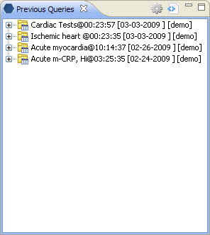
Figure 6. 1 Previous Query View

The query in the previous query is comprised of several levels that can be seen by expanding each level of the tree. These levels are outlined below:

Previous Query Name
The name of the previous query is the top level of the hierarchal tree and is comprised of the following components.
- Description – abbreviated name to describe the previous query.
- Time – the time the query was run.
- Date – the date the query was run.
- User Id – the user who ran the query.
Note: unless you are a manager you will only see your queries.

Results Folder
The results folder contains the results of the query. Expand the view by clicking on the plus sign () to see the query results.

Results
There are two types of results; (1) Patient List and (2) Patient Count. The Timeline and Patient Count check boxes located in the Query Tool View will determine which results are included in the previous query.

Patient List
The Patient List () appears if Timeline was checked at the time the query was run. The list contains all the patients that met the search criteria. Included in the list are the Patient ID and basic demographic information.

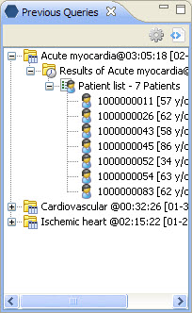
Figure 6. 2 Patient List

Number of Patients
The Number of Patients () appears if Patient Count was checked at the time the query was run. The actual number is displayed in the tool tip, which can be seen by hovering over it. The number that displays is the number of patients who met the criteria defined in the creation of the query.

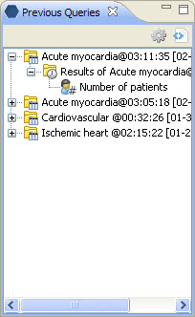
Figure 6. 3 Number of Patients

