Display Options
Users can define how many previous queries to display and the order in which they will appear in the list. The display options are set in the Previous Queries Options Dialog window (Figure 6.7), which can be accessed by clicking on the Options () button.

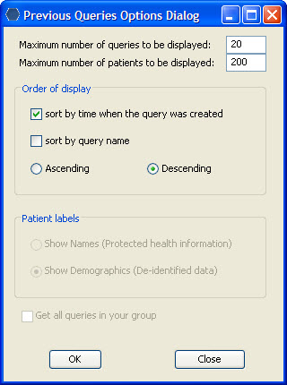
Figure 6. 1 Options Dialog Box

Maximum to Display

Queries to Display
The Maximum number of queries to be displayed defines how many previous queries will display in the Previous Query View. Once the maximum number is reached the oldest query will no longer appear in the workplace.

Recommendation: Use the Workplace View to save those previous queries that will be used often. This will prevent the lost of the query in the event that the maximum number to display has been reached.

Patients to Display
The Maximum number of patients to be displayed is used when the system is retrieving the list of patients to display in the Previous Query View. Once the maximum number is reached a message (Figure 6.8) will appear informing you that you have reached the maximum defined and that continuing to retrieve all the patients in the list may affect performance. You will have the option to continue or to cancel the action.

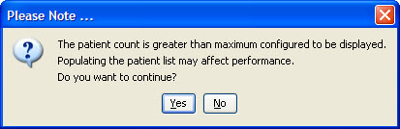
Figure 6. 2 Patient Count Message

Order of Display

Sort by Time
Selecting sort by time when the query was created will sort the queries in the Previous Query View by the date and time the query was created. Once you select to sort by time, you need to define whether or not it will be in Ascending or Descending order.
Ascending: displays the oldest query first.
Descending: displays the newest query first.

Note: Renaming a query will not affect the sort order as the date and time is stored with the previous query.

Sort by Query Name
Selecting sort by query name will sort the queries in the Previous Query View alphabetically by the name of the query. Once you select to sort by name, you need to define whether or not it will be in Ascending or Descending order.
Ascending: queries are displayed in alphabetical order with the beginning of the alphabet at the end of the list. (Z to A)
Descending: queries are displayed in alphabetical order with the beginning of the alphabet at the beginning of the list. (A to Z)

