Refresh the List
Users can refresh the list of previous queries by selecting Refresh All from the drop-down list.

- Using the right mouse button, click on any of the previous queries in the list.
- A drop down list will open.

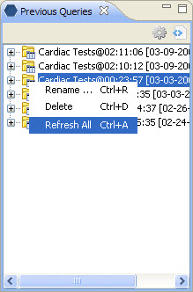
Figure 6. 1 Refresh All

- Select Refresh All from the list.

