Add to Query Tool View
A previous query can be added to the query tool view by simply dragging the query name from Previous Query View.

Add Previous Query To Query Tool View
- Click on the previous query and drag the item over to the Query Tool View.
- Drop the previous query into the Query Name (Figure 6.9).

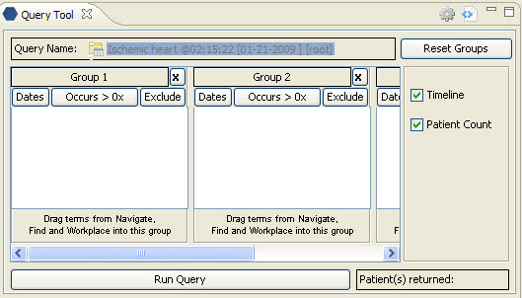
Figure 6. 1 Dropping Previous Query in Query Tool View

- The concept(s) associated with the previous query will display in the appropriate group(s) and the name of the query will appear at Query Name (Figure 6.10).

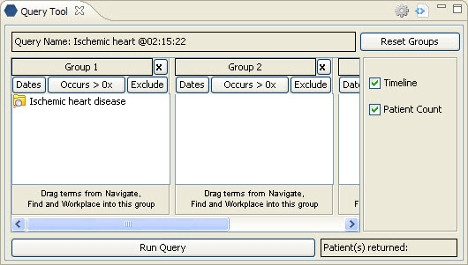
Figure 6. 2 Previous Query Added to Query Tool View

