Add to Timeline View
The timeline view displays the information in a graphical representation of a chronological sequence of events.

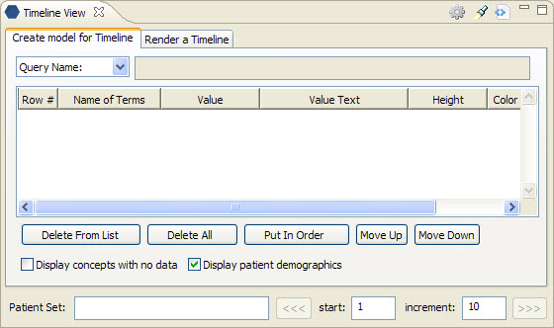
Figure 6. 1 Timeline View

Add Previous Query To Timeline View
- Highlight the previous query by clicking on the name of the query.
- While holding the left mouse button down, drag the previous query name to the Timeline View.
- Drop the previous query into concept list section of the Create model for timeline tab.
- The concepts and patient set associated with the previous query will now appear in the Timeline view.

Add Patient Set To Timeline View
- Click on the plus sign () next to the previous query that contains the patient set.
- Click on the plus sign () next to the results folder.
- Click on patient list ().
- While holding the left mouse button down, drag the patient list to the Timeline View.
- Drop the patient list into the Patient Set field located on the Create model for timeline tab.
- The patient set field will now display the number of patients in the patient list.

