Add to Workplace View
Information in the workplace is related to the most common concepts and queries that an individual uses and in essence becomes their personal workplace.

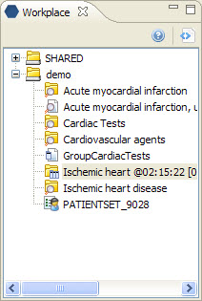
Figure 6. 1 Workplace View

Add Previous Query To Workplace View
- Highlight the previous query by clicking on the name of the query.
- While holding the left mouse button down, drag the previous query name to the Workplace View.
- Drop the previous query into either your workplace folder or the shared folder.
- The previous query will now appear in the workplace with the same name.

Add Patient Set To Workplace View
- Click on the plus sign () next to the previous query that contains the patient set.
- Click on the plus sign () next to the results folder.
- Click on patient list ().
- While holding the left mouse button down, drag the patient list to the Workplace View.
- Drop the patient list into either your workplace folder or the shared folder.
- The patient list will now appear in the workplace.

Add A Patient To Workplace View
- Click on the plus sign () next to the previous query that contains the patient set.
- Click on the plus sign () next to the results folder.
- Click on the plus sign () next to patient list.
- Click on the patient () to be copied.
- While holding the left mouse button down, drag the patient to the Workplace View.
- Drop the patient list into either your workplace folder or the shared folder.
- The patient will now appear in the workplace.

Add Patient Count To Workplace View
- Click on the plus sign () next to the previous query that contains the patient set.
- Click on the plus sign () next to the results folder.
- Click on number of patients ().
- While holding the left mouse button down, drag the number of patients to the Workplace View.
- Drop the number of patients into either your workplace folder or the shared folder.
- The number of patients will now appear in the workplace as patient count ().

