Add Concepts
Concepts can be added to the query tool view by simply dragging the concept from one of the following views.

Navigate Terms View
The Navigate Terms view contains a hierarchical display of all the concepts that can be used to search the database.

Note: How the items are grouped and displayed is dependent on how the database is setup.

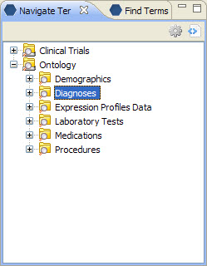
Figure 7. 1 Navigate Terms View

Add Concept From Navigate Terms View
- Expand the folders that contain the concept or grouping of concepts that you want to add.
- Click on the concept/term and drag the item over to the Query Tool View.
- Drop the concept into the panel labeled Group 1 (Figure 7.9).

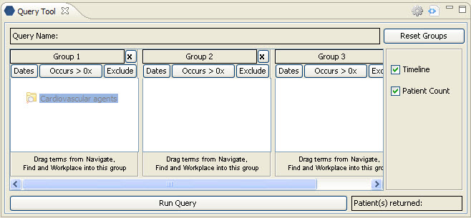
Figure 7. 2 Dropping Concept

- The concept will display (Figure 7.10).

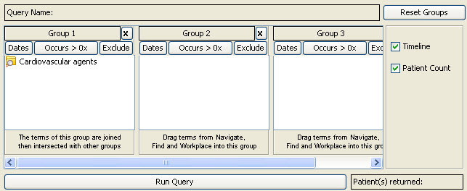
Figure 7. 3 Concept in Group 1

Find Terms View
The Find Terms view provides a way to search for a particular concept. There are two basic methods that can be used to find terms: (1) Search by Names and (2) Search by Codes.

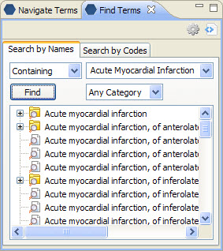
Figure 7. 4 Find Terms View

Add Concept From Find Terms View
- After searching for the term(s) you want to add, click on the concept/term and drag the item over to the Query Tool View.
- Drop the concept into the panel labeled Group 1 (see Figure 7.9).
- The concept will display (see Figure 7.10).

Workplace
Information in the workplace is related to the most common concepts and queries that an individual uses and in essence becomes their personal workplace.

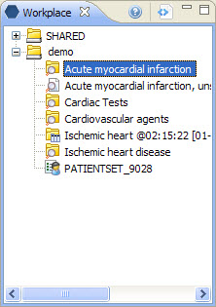
Figure 7. 5 Workplace View

Add Concept From Workplace View
- Find the set of concepts you want to add (either in your folder or a shared folder).
- Click on the concept and drag it over to the Query Tool View.
- Drop the concept into the panel labeled Group 1 (see Figure 7.9).
- The concept will display (see Figure 7.10).

