Add a Panel/Group
Three panels are typically displayed as part of the standard query tool view. Some complex queries may require the use of additional panels.

Note: In order to add a panel, the previous panels must contain at least one concept.

- On the right hand side of the panels section is a button labeled Add Group (Figure 7.18).

Note: You may need to use the horizontal scroll bar located at the bottom of the panel section to see the button.

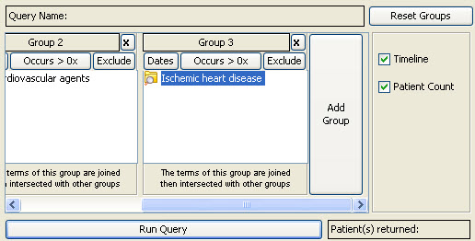
Figure 7. 1 Add Group Button

- Click on this button.
- A new panel will be added.

