Add Previous Query
A previous query can be added to the query tool view by simply dragging the query name from one of the following views.

Previous Query View
The previous query view displays the queries that were run by the user.

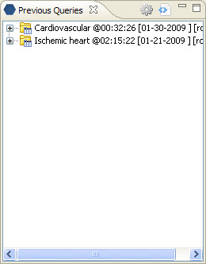
Figure 7. 1 Previous Queries View

Add Previous Query From Previous Query View
- Click on the previous query and drag the item over to the Query Tool View.
- Drop the previous query into the Query Name (Figure 7.14).

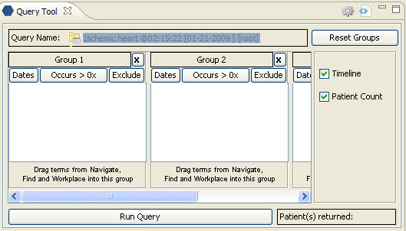
Figure 7. 2 Dropping Previous Query

- The concept(s) associated with the previous query will display in the appropriate group(s) and the name of the query will appear at Query Name (Figure 7.15).

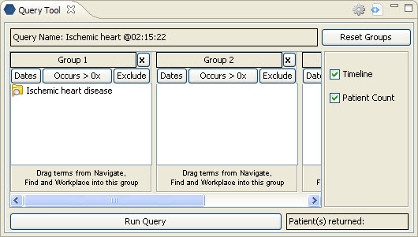
Figure 7. 3 Previous Query Added

Note: When you run the query it will receive a new name. This is to distinguish the first previous query from the second.

Workplace View
Information in the workplace is related to the most common concepts and queries that an individual uses and in essence becomes their personal workplace.

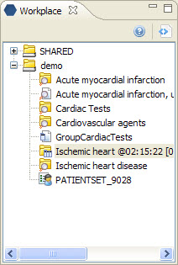
Figure 7. 4 Workplace View

Add Previous Query From Workplace View
- Find the previous query you want to add (either in your folder or a shared folder).
- Click on the previous query and drag it over to the Query Tool View.
- Drop the previous query into the Query Name (see Figure 7.14).
- The concept(s) associated with the previous query will display in the appropriate group(s) and the name of the query will appear at Query Name (see Figure 7.15).

