Add Query Definition
A query definition can be added to the query tool view by simply dragging the query name from the workplace view.

Add Query Definition From Workplace View
- Find the query definition you want to add (either in your folder or a shared folder).
- Click on the query definition name and drag it over to the Query Tool View.
- Drop the query definition into the Query Name.

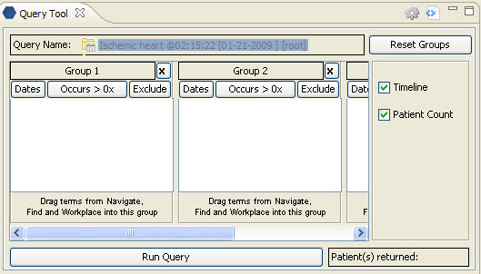
Figure 7. 1 Dropping into Query Name

- The concept(s) associated with the query definition will display in the appropriate group(s) and the name of the query will appear at Query Name.

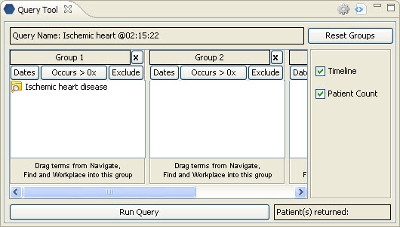
Figure 7. 2 Query Added

