Running a Query
Once the query has been created and the analysis selected, the final step to retrieve your information is to run the query. This is done by clicking on the Run button in the query tool.
Once you begin the process of running the query the button will change to say cancel and an image will appear indicating the process is still running (Figure 7.36).

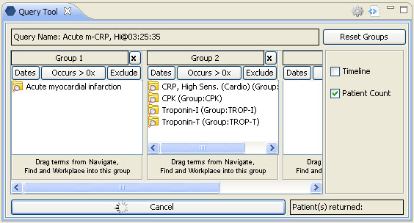
Figure 7. 1 Query Running Indicator

