Saving a Group Template
Users can define a group of concepts that they frequently run and save them in their workplace view. This grouping of concepts is referred to as a group template ().

- In the query tool, click on the group name that you want to save.
- While holding the left mouse button down, drag the group name to the Workplace view.
- Drop the group name into either your workplace folder or the shared folder.
- The group will now appear in the workplace as a group template. The name will be the group name as it appears in the query tool plus a unique identifier that is randomly assigned.

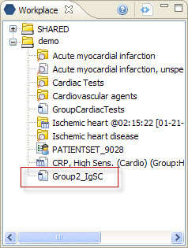
Figure 7. 1 Group Template in Workplace

