Layout of the Import Status Tab

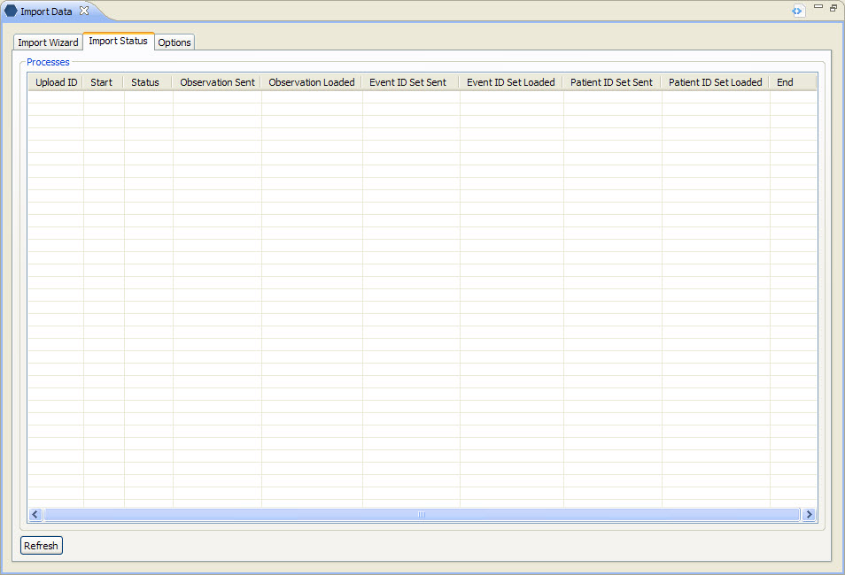
Figure 4. 1 Import Status Tab

Column Name | Description / Use
Upload ID | The unique identifier assigned to the batch when the data was uploaded to the table.
Start | Date the upload process started.
Status | Displays where the batch is in the upload process.
Observation Sent | Displays the number of observation records included in the batch to be uploaded.
Observation Loaded | Displays the number of observation records in the batch that were loaded into the table.
Event ID Set Sent | Displays the number of event records included in the batch to be uploaded.
Event ID Set Loaded | Displays the number of event records in the batch that were loaded into the table.
Patient ID Set Sent | Displays the number of patient records included in the batch to be uploaded.
Patient ID Set Loaded | Displays the number of patient records in the batch that were loaded into the table.
End | Date the upload process ended.

Refresh Button
Clicking on the Refresh button will force the view to refresh and display the latest status of the upload batches.

