Course Management System Documentation

Pokémon Team

Funing Teng

Hardik Parikh

Tailong Si

Hangyi Zhao

Bhakti Chheda

Guldasta Kozho

Introduction

**Purpose**

The purpose of this project is to design, document and implement a course management system which keeps courses records, students’ attendance, grading and so forth.

**Technology**

The Course Management System a web based application utilizing Angular2, TypeScript, Mongodb, NodeJS and Express. In 2015, a new version of JavaScript(ES2015) was approved that revolutionizes JavaScript Programming. Web Components enable Angular2 applications to be built out of reusable building blocks and encapsulate internal logic. ES2015 provides classes and a solid system for loading Angular modules. TypeScript brings types that enable a simpler and more robust syntax for building large-scale applications. Mongodb is an open-source document database and leading NoSQL database, which has deep query-ability, easy to scale, number of fields, content, and size of the document can be differ from one document another, which fit the “small” - big data world. NodeJS is a very powerful JavaScript-based framework/platform built on Google Chrome’s JavaScript V8 Engine. It is developed for intensive web applications like single-page application. We choose this development stack is to respond to challenge of maximizing performance and a trend that emphasizes mobile-first development. So we adopt the latest web technologies and incorporating them into a framework for modern browser.

The document covers use case diagrams, use case description, activity diagrams, E-R diagrams, class diagrams. The team meets frequently for brainstorming and allocating tasks.

**Development Plan**

The development plan states the tasks needed to be completed to deliver the project described in this plan. This deployment plan includes the tasks needed to complete the project, the order each task needs to be completed, and what resources are needed to complete each project.

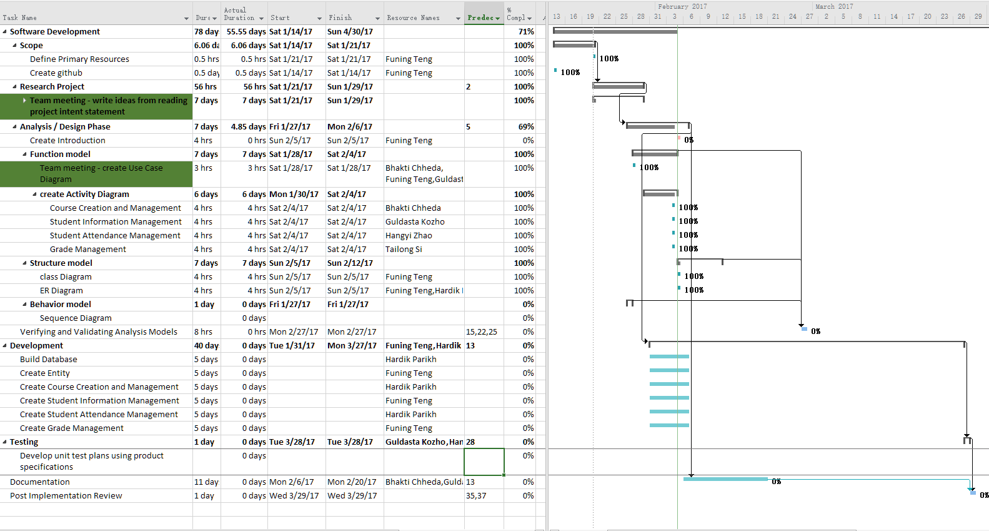

Use Case Diagram

