ITMD 513-01

Lab 3

Programmer: FNU Tripti (A20503656)

Date: 06/26/2022

**Run Time Output**

**Run #1: Screenshot for three failed tries for inputting wrong PINs.**

* **The correct PIN is “ft90” and alphanumeric four digits PIN**
* **This screenshot also shows the number of retries attempt left.**
* **Displaying appropriate error messages on the failed tries.**

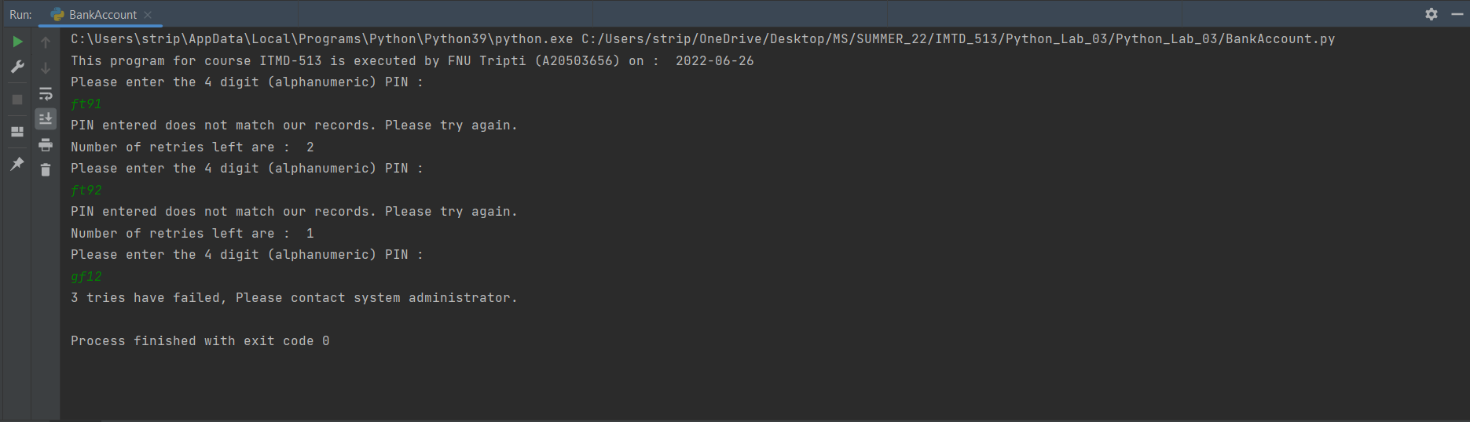

**Run #2: Screenshot for 1 failed try and second successful try**

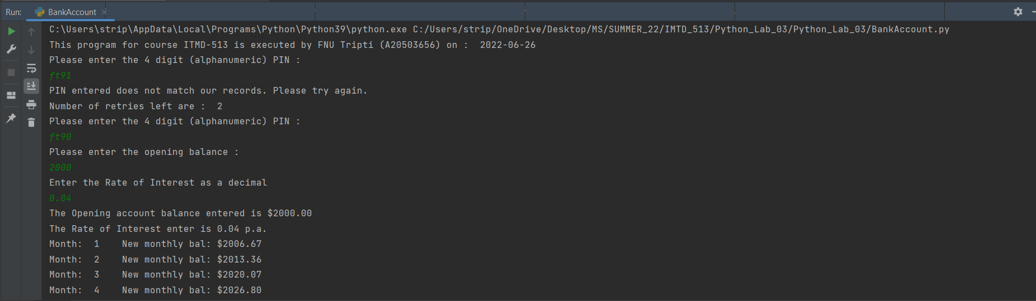

**Run #3: Screenshot for 2 failed tries and third time successful attempt**

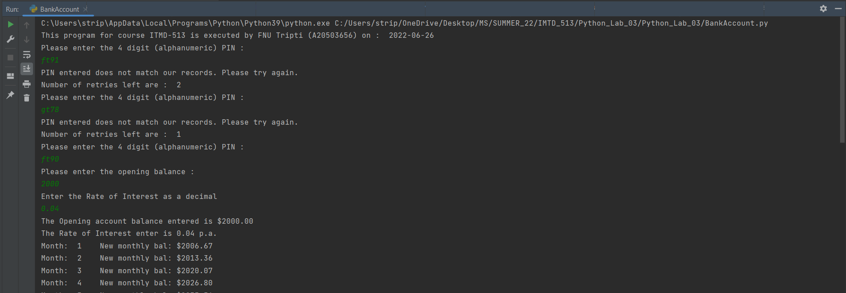

**Run #4: Displaying the accumulated Interest amount.**

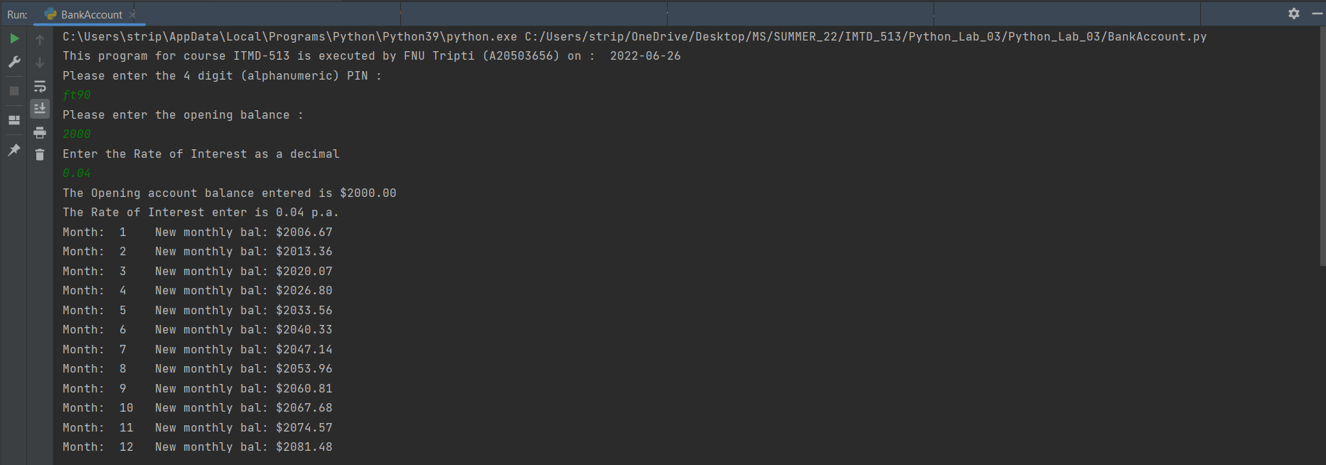

**Run #5: Modification required for the GRAD students (special formatting).**

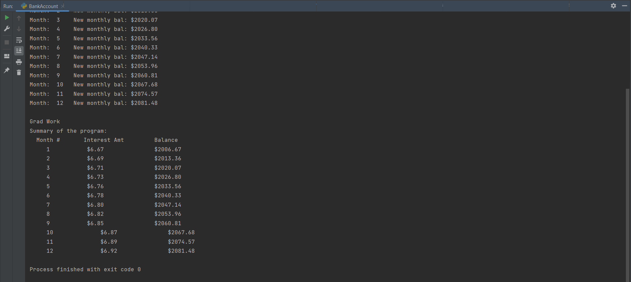

**Source Code:**

from datetime import date  
  
# This program calculates the accumulated interest over a time of 12 months.  
  
# Programmer Information  
# Name: FNU Tripti  
# A-ID: A20503656  
# Course: ITMD-513  
# Date: 06/25/2022  
# Lab #: 3  
  
print("This program for course ITMD-513 is executed by FNU Tripti (A20503656) on : ", date.today())  
  
  
# Declaration of function to calculate the interest and the total amount  
def calculate_bank_balance():  
 # Declaration and initialization of variables to store the bank balance  
 bank_balance = 0.0  
 bank_balance_grad = 0.0  
  
 # Declaration and initialization of the variable to store the rate of Interest  
 rate_of_interest = 0.0  
 rate_of_interest_grad = 0.0  
  
 # Prompt user to enter the opening account balance  
 print("Please enter the opening balance :")  
  
 bank_balance = float(input())  
 bank_balance_grad = bank_balance  
  
 # Prompt the user enter the rate of Interest  
 print("Enter the Rate of Interest as a decimal")  
  
 rate_of_interest = float(input())  
 rate_of_interest_grad = rate_of_interest  
  
 print("The Opening account balance entered is $%.2f" % bank_balance)  
 print("The Rate of Interest enter is %.2f p.a." % rate_of_interest)  
  
 # Calculation of Interest every month and accumulated balance  
 # Starting the for loop to run iterations for 12 months of a year  
 for x in range(1, 13):  
 bank_balance = bank_balance + (bank_balance * rate_of_interest / 12)  
 print("Month: ", x, "\t New monthly bal: $%.2f" % bank_balance)  
  
 # Printing Summary as part of Grad work  
 print()  
 print("Grad Work")  
 print("Summary of the program:")  
 print(" Month #\t\tInterest Amt\t\t Balance")  
 for z in range(1, 13):  
 accumulated_interest = (bank_balance_grad * rate_of_interest_grad / 12)  
 bank_balance_grad = bank_balance_grad + accumulated_interest  
 print("\t", z, "\t\t\t $%.2f" % accumulated_interest, "\t\t\t\t $%.2f" % bank_balance_grad)  
  
  
# Declaration of variable to store decision of PIN Entering  
success = False  
  
# Declaration of variable to store the 4 digit bank PIN Code  
bankPinCode = "ft90"  
  
# For loop to implement the correct pin with 3 retries  
for y in range(1, 4):  
 print("Please enter the 4 digit (alphanumeric) PIN : ")  
 enteredPin = input()  
  
 if bankPinCode == enteredPin:  
 success = True  
 break  
 else:  
 if y < 3:  
 print("PIN entered does not match our records. Please try again.")  
 print("Number of retries left are : ", 3 - y)  
 else:  
 print("3 tries have failed, Please contact system administrator.")  
  
# Calling the method that calculates interest and total amount on the basic of the success variable.  
if success:  
 calculate_bank_balance()

**Questionnaire**

1. **Explain how looping techniques (repetitive program control) are used in this program application.**

**Ans.** The looping techniques are being used in this program in the following places:

1. To implement the PIN protection functionality. I have made use of for loop to loop exactly three times to keep track of the tries of the user while entering the credentials information.
2. To implement the calculation of the interest and the accumulated amount over the period of 12 months.

* I have made use of range function of python to implement both the loops as explained in the class.

1. **Loops often incorporate accumulating variables which amass a sum that builds every time the loop is executed. Did your application include any accumulating variables? What amount(s) were accumulated?**

**Ans.** I have used the loop to calculate the accumulated amount with the interest over the time of 12 months. The variables used to calculate the amount is **bank_balance** and **bank_balance_grad**.

**bank_balance** variable is used to calculate the normal implementation whereas the **bank_balance_grad** is just a duplicate variable that I have used to implement the special formatting required as part of the grad work.

1. **Prior to their use in a looping structure, accumulating variables are often declared and initialized. For an accumulating sum variable, what is the typical value for which the variable is initialized?**

**Ans.** The typical value with which an accumulating variable are often declared, if not instructed otherwise is **0.** Usually, the accumulating variables are initialized with 0 or 0.0 if the variable is used to store a floating decimal point value.

For Example: bank_balance = 0.0

1. **Which datatype is the following variable associated with?**

**success = False**

**Ans.** The success variable declared here is associated with Boolean data type. Which can have two values **False** or **True.** The class associated with this data type is “bool” in Python language.

1. **What have you learned from performing and coding for this lab assignment?**

**Ans.** I have learned the following in this lab assignment.

* The power of looping. The ability of python language to loop is simply one of strongest constructs of the python programming.
* The efficient use of accumulating variables to calculate the complex problems such as compound interest.
* Making efficient use of the Boolean data type to implement the take the decisions in a repetition structure.
* Also revisited the concept of building user defined functions to implement the reusability and conditional calling.
* Learned the use of the local variables.