ITMD 513-01

Lab 6

Programmer: FNU Tripti (A20503656)

Date: 07/15/2022

**Run Time Output**

**Screenshot of running the program initially before adding a new student in the file (Starter Code run).**

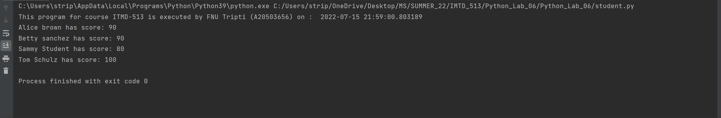

**Screenshot of running the program after adding a new student (myself) in the data.txt and object**

**Screenshot of data.txt file**

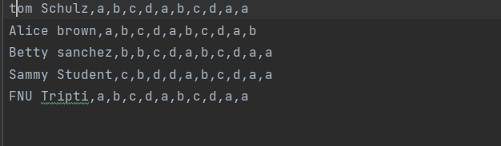

**Screenshot of the output (also contains the code for idealizing the names.)**

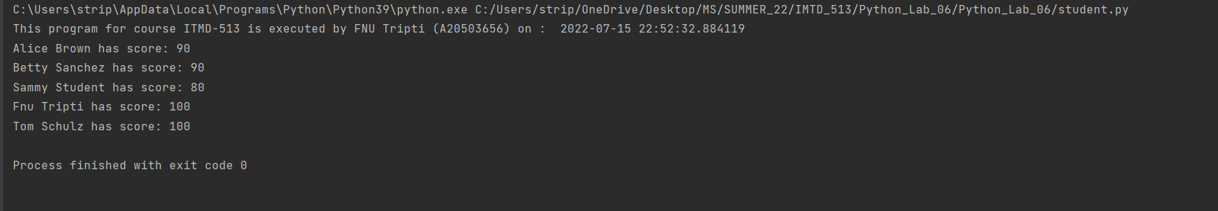

**Screenshot of running the program after adding average grade and average of individual students and overall average and overall aggregate. (Required for the Grad work)**

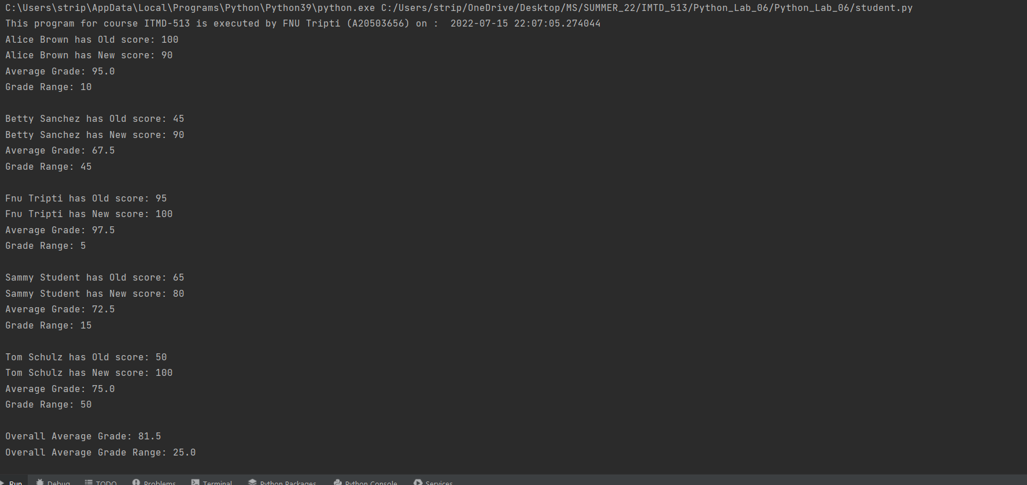

**I have made use of the tile() function to display the names appropriately**

**Source Code:**

from datetime import datetime  
  
class Student:  
 Scores = {}  
  
 # Programmer Information  
 # Name: FNU Tripti  
 # A-ID: A20503656  
 # Course: ITMD-513  
 # Date: 07/15/2022  
 # Lab #: 6  
  
 # initializing the constructor method  
 def __init__(self, name, grade):  
 self.name = name  
 self.grade = grade  
  
 def getScores(self):  
  
 answer_key = []  
 # read into answer_key list, the answer key from file  
 answer_key = [line.strip() for line in open("answers.txt", 'r')]  
  
 student_answers = []  
 # read into student_answers list, student answers from file  
 student_answers = [line.strip().split(',')  
 for line in open("data.txt", 'r')]  
 total_score = 100  
  
 # place additional code statements here for the above function  
 # ---start your loop processing logic here---#  
  
 for i in range(len(student_answers)):  
 if student_answers[i][0] == self.getName():  
 for key in range(len(answer_key)):  
 if answer_key[key] != student_answers[i][key + 1]:  
 total_score -= 10  
  
 # ---end your loop processing logic here---#  
  
 # ---continue the class definition#  
  
 Student.Scores[self.getName()] = total_score  
  
 def getName(self):  
 return self.name  
  
 # Method added to get the current grades.  
 def getGrades(self):  
 return self.grade  
  
 @staticmethod  
 def printSummary(sorted_list):  
 print("This program for course ITMD-513 is executed by FNU Tripti (A20503656) on : ", datetime.now())  
 overall_average = 0.0  
 overall_aggregate = 0.0  
 count = 0  
 for k, v in sorted_list:  
 # print(k, "has score:", v)  
 for w in range(len(student_objs)):  
 if k == student_objs[w].getName():  
 z = student_objs[w].getGrades()  
 print(k.title(), "has Old score:", z)  
 print(k.title(), "has New score:", v)  
 print("Average Grade:", ((z + v)/2))  
 print("Grade Range:", abs(z - v), "\n")  
 overall_average += ((z + v)/2)  
 overall_aggregate += abs(z - v)  
 count += 1  
  
 print("Overall Average Grade:", (overall_average/count))  
 print("Overall Average Grade Range:", (overall_aggregate/count))  
  
 @staticmethod  
 def sortDict():  
 return sorted(Student.Scores.items())  
  
 # ---end the class definition#  
  
  
student_objs = [  
  
 Student('Sammy Student', 65),  
 Student('Betty sanchez', 45),  
 Student('Alice brown', 100),  
 Student('tom Schulz', 50),  
 Student('fNU Tripti', 95)  
]  
  
for index in range(len(student_objs)):  
 student_objs[index].getScores()  
  
sortList = Student.sortDict()  
  
Student.printSummary(sortList)

**Questionnaire:**

1. **What is the purpose of this function?**

**def __init__()**

**Ans.** The **__init__()** is equivalent of the constructor of the Java in an object-oriented

approach. The __init__() method is called every time an object is created of a class. The method let the class initialize the object’s attributes. It is used within the classes.

1. **Is self considered a keyword in Python?**

**Ans.** The **self** keyword is used to represent an instance/object of the given class. It

Contains the reference of the current object of the class. This is equivalent to the

“this” object in the Java language. It provides the ability of holding data of

multiple objects to a class.

1. **What is meant by object - oriented programming?**

**Ans.** The **Object-Oriented Programming** is a programming paradigm that provides the

Structural method of program, which involves the creation of classes which serves as

the blueprint of the data. And it involves the creation of objects which is actually

instantiation of the class and holds the actual data. It also follows the principles

such as **Polymorphism, Inheritance, Abstraction etc.**

1. **How are text files used in your program code for this project?**

**Ans.** The text files are used as data store in this program. The text file **data.txt** is

Being used as the data store for all the individuals and their answers and text file

**answer.txt** is being used as the key which is used to store the correct answer key.

1. **What have you learned from performing and coding for this lab assignment?**

**Ans.** I have learned the following in this lab assignment:

1. **To make use of the for loop to iterate over the multi-dimensional array.**
2. **To make use of classes and objects to process the data.**
3. **To make use of static methods of a class.**
4. **More hands on the files processing part.**