ITMD 513-01

Lab 7

Programmer: FNU Tripti (A20503656)

Date: 07/18/2022

**Run Time Output**

**Screenshot for Initial Run with the contacts.py file provided by Professor**

1. **Added the title to the Frame as “My Contact List”**

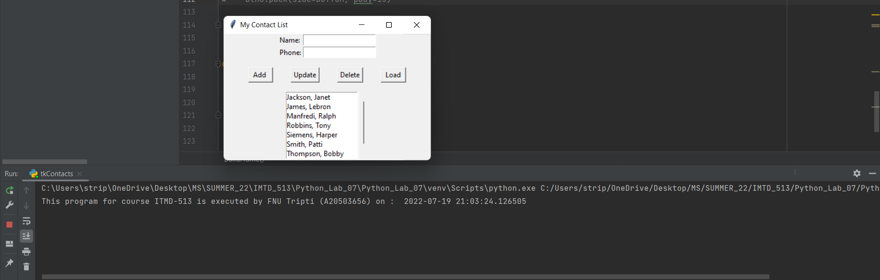

1. **Screenshot of the list box after the Save and Exit button have been added.**

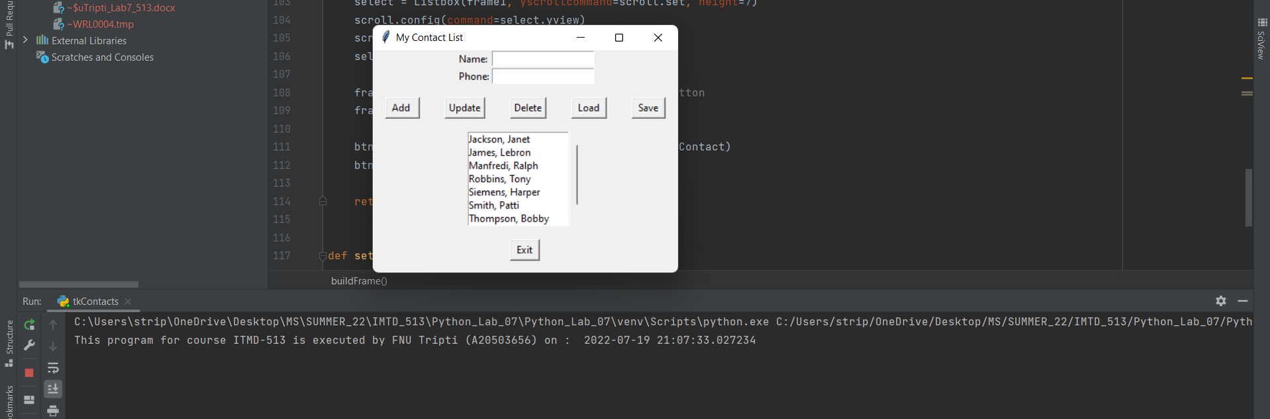

1. **Screenshot group of adding a name to the contact list**

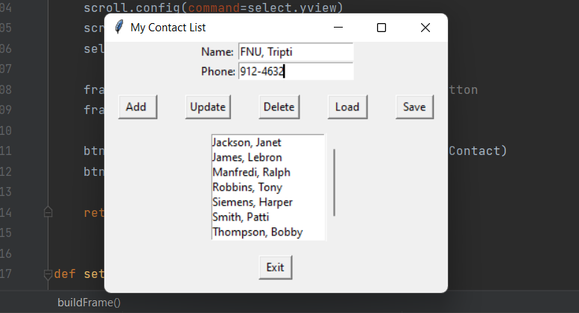

**On clicking the Add Button we can see the name has been added to the list and also shows a successful add message.**

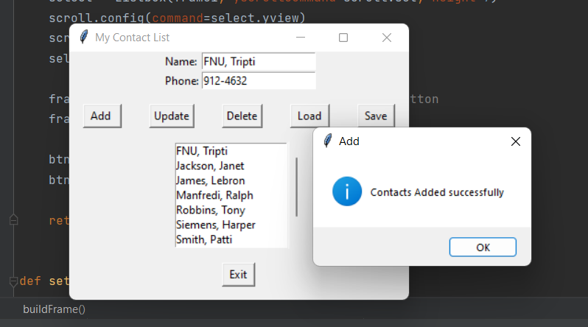

**Loading the added contact to see whether the phone number has been added or not?**

**Console also showing the selected index. Contact loaded successfully.**

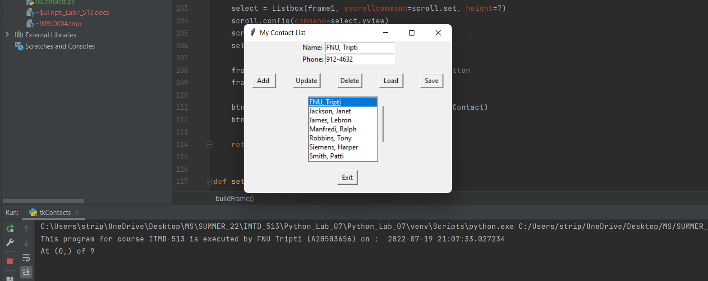

1. **Deleting the LeBron James Contact from the list**

**Message box displaying asking are you sure to delete.**

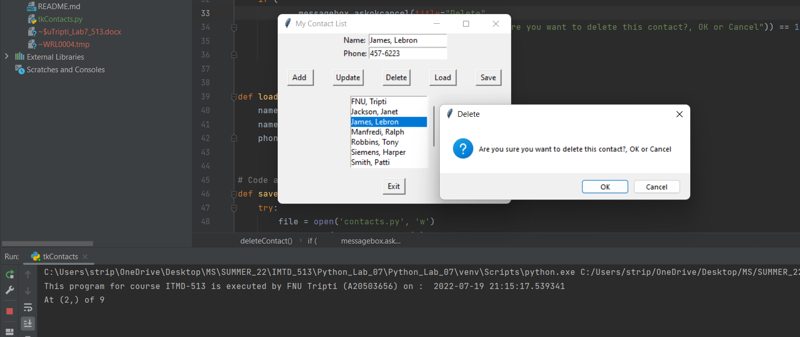

**On pressing OK on the message box we can see that LeBron, James have been deleted from the list.**

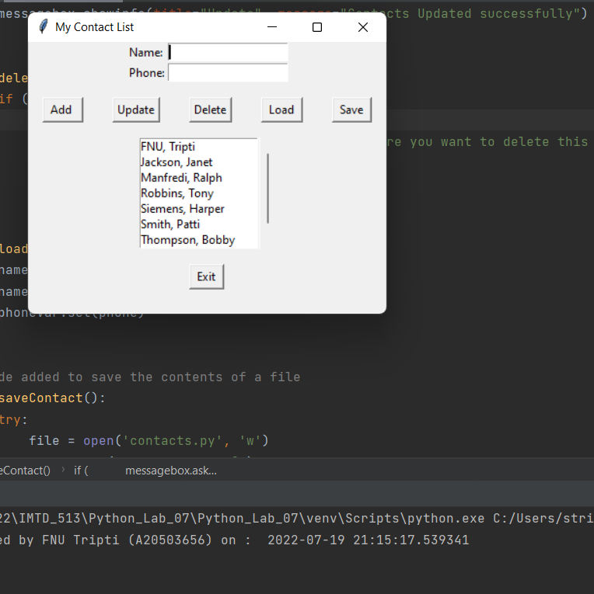

1. **Updating a contact information in the Contact List**

**Updating Janet Jackson to Michael Jackson and update her number to from 313-1352**

**to 313-1111**

**A message box displays showing info that contact has been updated and we can see that in the list too.**

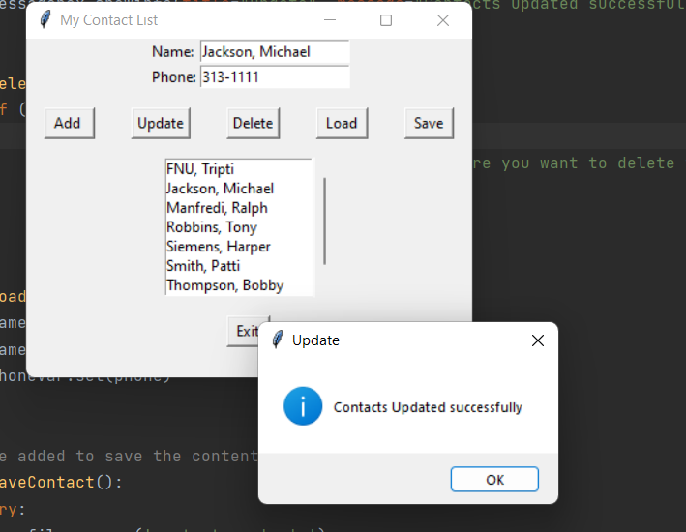

1. **Showing the Save functionality**

**Screenshot of the file before pressing the save button**

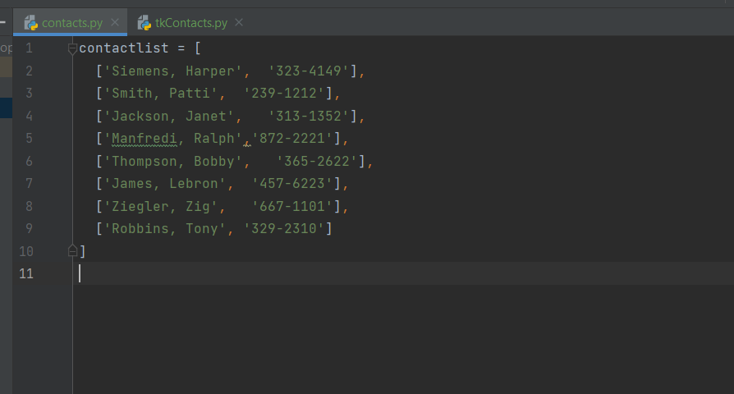

**Screenshot of the application after pressing the save button**

**A message box shows that data has been written into the file without any exception.**

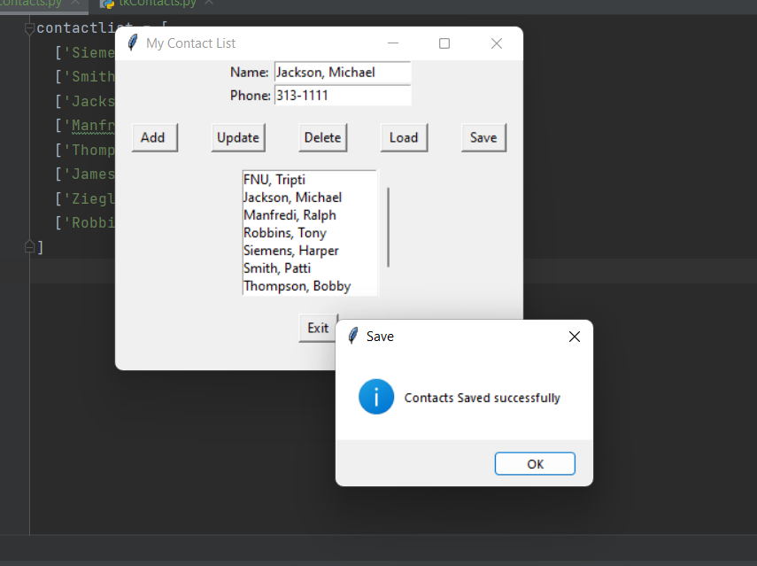

**Screenshot of the contacts.py file after the data has been saved**

**We can clearly see that FNU Tripti has been added to the file, Janet Jackson has been updated to Michael Jackson and Lebron James has been deleted**

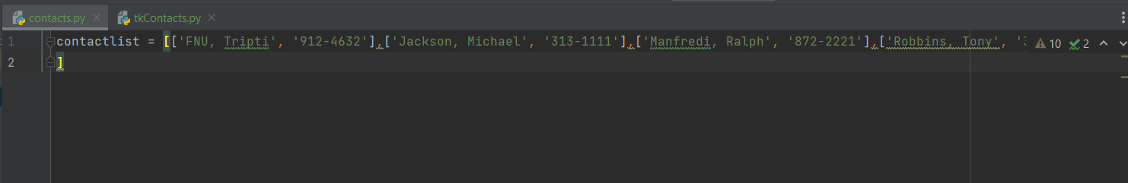

**Re-running the application after pressing the save button**

**The new application is picking up the updated data modified in the last run.**

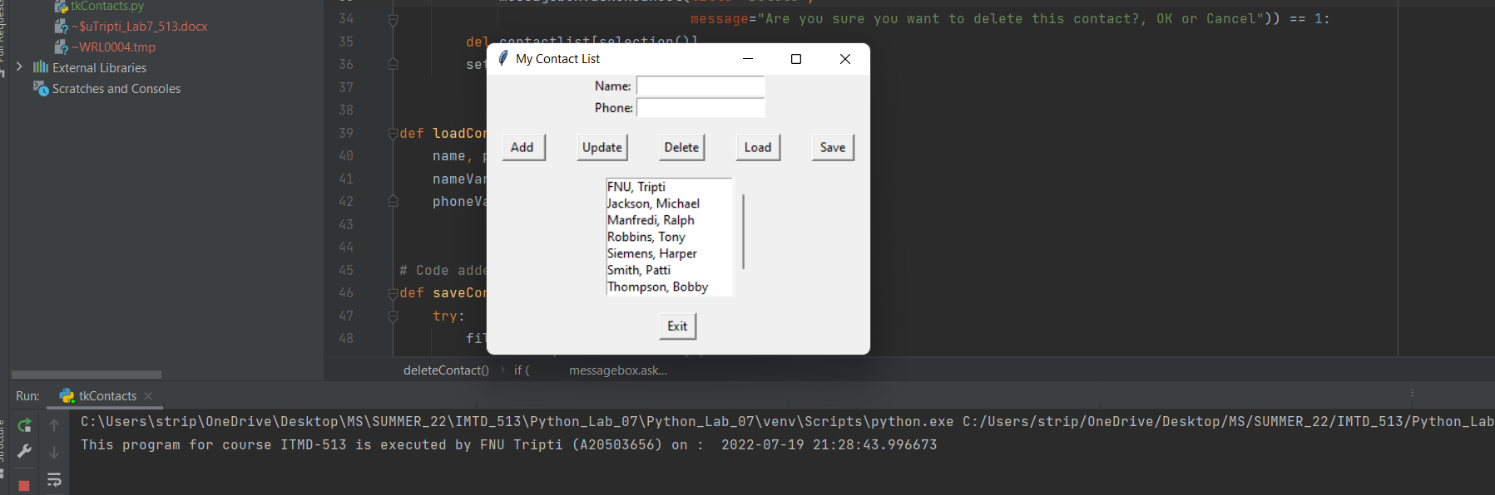

1. **Showing the exit functionality (Grad work)**

**We can clearly see the message being displayed and the Exit button on the Frame.**

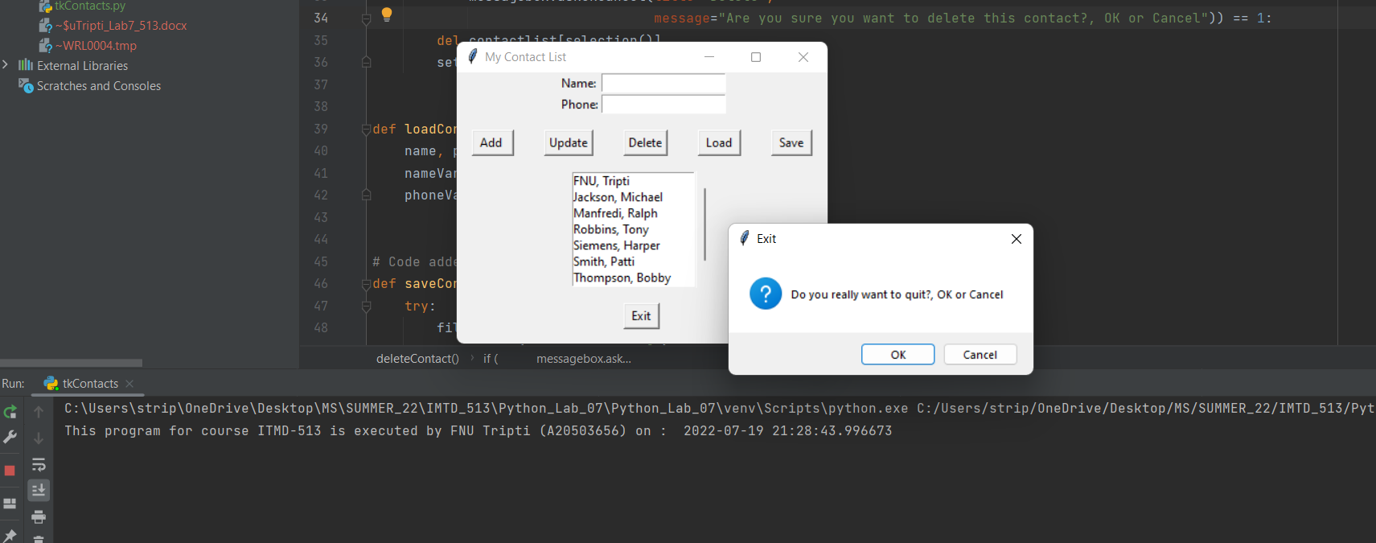

**After pressing the exit button we can clearly see that error message displays on the console**

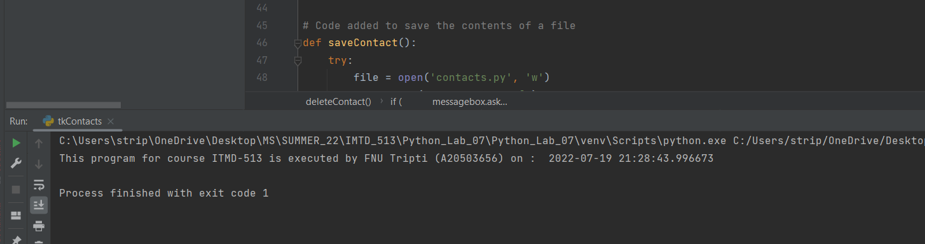

**Source Code:**

from tkinter import *  
from contacts import *  
from tkinter import messagebox  
import os  
from datetime import datetime  
  
# Programmer Information  
# Name: FNU Tripti  
# A-ID: A20503656  
# Course: ITMD-513  
# Date: 07/18/2022  
# Lab #: 7  
  
def selection():  
 print("At %s of %d" % (select.curselection(), len(contactlist)))  
 return int(select.curselection()[0])  
  
  
def addContact():  
 contactlist.append([nameVar.get(), phoneVar.get()])  
 setList()  
 messagebox.showinfo(title="Add", message="Contacts Added successfully")  
  
  
def updateContact():  
 contactlist[selection()] = [nameVar.get(), phoneVar.get()]  
 setList()  
 messagebox.showinfo(title="Update", message="Contacts Updated successfully")  
  
  
def deleteContact():  
 if (  
 messagebox.askokcancel(title="Delete",  
 message="Are you sure you want to delete this contact?, OK or Cancel")) == 1:  
 del contactlist[selection()]  
 setList()  
  
  
def loadContact():  
 name, phone = contactlist[selection()]  
 nameVar.set(name)  
 phoneVar.set(phone)  
  
  
# Code added to save the contents of a file  
def saveContact():  
 try:  
 file = open('contacts.py', 'w')  
 file.write("contactlist = [")  
  
 for item in contactlist:  
 file.write("%s" % item + ",")  
 file.write("\n")  
 file.write("]")  
 file.close()  
 setList()  
 messagebox.showinfo(title="Save", message="Contacts Saved successfully")  
 except IOError as e:  
 print(e)  
  
  
def exitContact():  
 if (messagebox.askokcancel(title="Exit", message="Do you really want to quit?, OK or Cancel")) == 1:  
 os._exit(1)  
  
  
def buildFrame():  
 print("This program for course ITMD-513 is executed by FNU Tripti (A20503656) on : ", datetime.now())  
 global nameVar, phoneVar, select  
 root = Tk()  
 # Code added to show the title of the frame.  
 root.title("My Contact List")  
  
 frame1 = Frame(root)  
 frame1.pack()  
  
 Label(frame1, text="Name:").grid(row=0, column=0, sticky=W)  
 nameVar = StringVar()  
 name = Entry(frame1, textvariable=nameVar)  
 name.grid(row=0, column=1, sticky=W)  
  
 Label(frame1, text="Phone:").grid(row=1, column=0, sticky=W)  
 phoneVar = StringVar()  
 phone = Entry(frame1, textvariable=phoneVar)  
 phone.grid(row=1, column=1, sticky=W)  
  
 frame1 = Frame(root) # add a row of buttons  
 frame1.pack()  
 btn1 = Button(frame1, text=" Add ", command=addContact)  
 btn2 = Button(frame1, text="Update", command=updateContact)  
 btn3 = Button(frame1, text="Delete", command=deleteContact)  
 btn4 = Button(frame1, text=" Load ", command=loadContact)  
 btn5 = Button(frame1, text=" Save ", command=saveContact)  
 btn1.pack(side=LEFT, padx=15, pady=15)  
 btn2.pack(side=LEFT, padx=15, pady=15)  
 btn3.pack(side=LEFT, padx=15, pady=15)  
 btn4.pack(side=LEFT, padx=15, pady=15)  
 btn5.pack(side=LEFT, padx=15, pady=15)  
  
 frame1 = Frame(root) # allow for selection of names  
 frame1.pack()  
 scroll = Scrollbar(frame1, orient=VERTICAL)  
 select = Listbox(frame1, yscrollcommand=scroll.set, height=7)  
 scroll.config(command=select.yview)  
 scroll.pack(side=RIGHT, fill=Y)  
 select.pack(side=LEFT, fill=BOTH)  
  
 frame1 = Frame(root) # add a row for the exit button  
 frame1.pack()  
  
 btn6 = Button(frame1, text=" Exit ", command=exitContact)  
 btn6.pack(side=BOTTOM, pady=15)  
  
 return root  
  
  
def setList():  
 contactlist.sort()  
 select.delete(0, END)  
 for name, phone in contactlist:  
 select.insert(END, name)  
  
  
root = buildFrame()  
setList()  
  
root.mainloop()

**Contents of the contacts.py file**

contactlist = [['FNU, Tripti', '912-4632'],['Jackson, Michael', '313-1111'],['Manfredi, Ralph', '872-2221'],['Robbins, Tony', '329-2310'],['Siemens, Harper', '323-4149'],['Smith, Patti', '239-1212'],['Thompson, Bobby', '365-2622'],['Ziegler, Zig', '667-1101'],  
]

**Pasting the python files for the lab #7**

