Natural History of Syphilis

Syphilis is cause by a bacterium called Treponema pallidum (*T.Pallidum*). The majority of Syphilis transmission occurs via sexual contact. The clinical manifestation of the infection depends on the stage of the disease.

Syphilis can manifest in several overlapping stages, which are primary syphilis, secondary syphilis, latent syphilis (which is subdivided in to early latent and late latent), and tertiary syphilis [4–6](Figure 1). These stages are defined though their clinical symptoms.

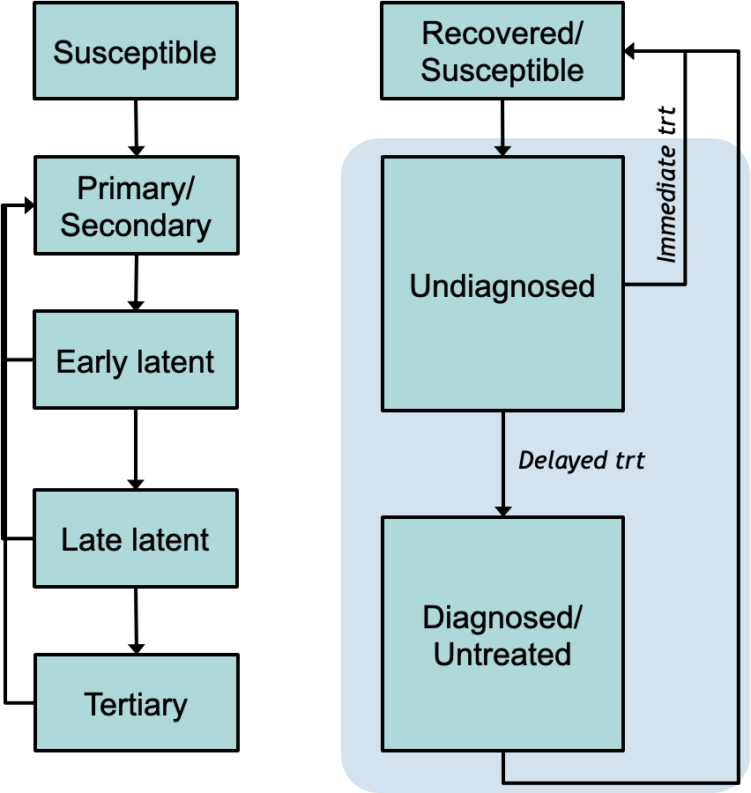

## Primary syphilis:

It is characterized by the development of a sore (chancre) that is usually painless and can resolve itself naturally. The median incubation period before the chancre appears is 21 days (range 3 to 90 days). Chancres heal spontaneously within 3-6 weeks even in the absence of treatment. The chancre represents an initial local infection, but syphilis quickly becomes systemic with widespread dissemination of the spirochete. (1)

* Delay to develop chancre: 3weeks [10-90days] (1, 2)
* Delay to heal chancre: 2-6 weeks (1, 2)
* Computing overall duration: 6-9weeks [range 3- 19weeks]
* Computing the infectiousness ???

>> lower probability of discovering chancre in MSM and women(2):

*The chancre usually becomes indurated and will progress to ulceration but typically is not purulent. In heterosexual men, primary chancres most commonly occur on the penis, but 32 to 36% of homosexual men have primary chancres in other sites, including the rectum, anal canal, and oral cavity (146, 204). In women, the primary chancre usually occurs on the labia or cervix. Because the chancre is painless and may be located in an inconspicuous anatomical site, diagnosis of syphilis in women and homosexual men is sometimes delayed until later disease manifestations become apparent.*

## Secondary syphilis

It’s predominant clinical sign is the development of a rash that appears from 2 to 8 weeks after the chancre develops and sometimes before it heals. The skin rash usually heals without scarring within 2 months. Approximately 25% of individuals with untreated infection develop a systemic illness that represents secondary syphilis(1). Similar to primary disease, the acute manifestations of secondary syphilis typically resolve spontaneously, even in the absence of therapy, except in the case of severe cutaneous ulcerations called lues malign. Occasionally, untreated patients experience additional episodes of relapsing secondary syphilis, which can occur for up to five years after their initial episode.

* Proportion of people developing secondary syphilis: 25% (1, 2)
* Delay to develop secondary syphilis: 2-8 weeks after chancre develops (1, 2)
* Delay to heal in absence of treatment: 1-2months (1), within 3 months of appearance (2)
* Percent noticing the rash or other symptoms to seek care
* Percent experiencing relapsing secondary syphilis
* Infectiousness

## Latent Syphilis

Latent phase refers to the period when a patient is infected with *T. pallidum* (as demonstrated by serologic testing) but has **no**symptoms. Latent syphilis is typically divided into early (if initial infection occurred within the previous 12 months) and late (if initial infection occurred >12 months ago).If the timing of an infection is not known, late latent syphilis is presumed.

* Patients with late latent disease are not considered infectious to their recent sexual contacts since they do not have lesions that can transmit disease.(1)
* Pregnant women with latent syphilis can transmit *T. pallidum* to their fetus for up to four years after acquisition.(1)

**Relapse**: in 25% of patients, a relapse to secondary syphilis can occur during the latent period. Latent disease is arbitrarily divided into early and late syphilis based on the time to spontaneous mucocutaneous (infectious) relapse of untreated patients. About 90% of first relapses occur within 1 year, 94% occur within 2 years, and the rest occur over 4 years. Due to high risk of relapse during the early stage, it’s often considered as infectious*. (3)*

Infectiousness=0 (unless pregnant)

## Late syphilis

Approximately 25 to 40 percent of patients with untreated syphilis can develop late disease at anytime between 1 to 30 years after primary infection. It is not necessary for individuals to have experienced clinically symptomatic primary or secondary syphilis prior to developing late syphilis.

The most common manifestations include: Cardiovascular syphilis (especially aortitis), Gummatous syphilis (granulomatous, nodular lesions that are rare, can occur in a variety of organs, usually skin and bones), CNS involvement (particularly general paresis and tabes dorsalis)

* **Tertiary syphilis** — Tertiary syphilis describes patients with late syphilis who have symptomatic manifestations involving the cardiovascular system or gummatous disease (granulomatous disease of the skin and subcutaneous tissues, bones, or viscera) or neurologic involvement. Appearance of these presentations is dependent on where T.Palldium dissemination occurs within the body

## Neurosyphilis

Classically, neurological complications of syphilis have been associated with tertiary disease, but studies have demonstrated that penetration of the central nervous system (CNS) by T. pallidum occurs during earlier stages of disease. About 40% of early syphilis patients and 25% of individuals with latent infection meet at least one of the diagnostic criteria for neurosyphilis (2).*The prognostic implications of CNS invasion are difficult to determine. The majority of persons with CNS invasion by T. pallidum appear to resolve or control CNS treponemes; however, there are no known indicators for subsequent development of symptomatic neurosyphilis*

|  |  |
| --- | --- |
| Parameter |  |
| **Durations** |  |
| Duration of primary syphilis | Delay to develop chancre: 3weeks [10-90days] (1, 2)  3-4 weeks (4)  Delay to heal chancre: 2-6 weeks (1, 2)   * Estimated overall duration: 6-9weeks [range 3- 19weeks] |
| Duration of secondary syphilis | Delay to develop secondary syphilis: 2-8 weeks after chancre develops (1, 2)  Delay to heal in absence of treatment: 1-2months (1), within 3 months of appearance (2)   * Estimated overall duration: 2-5months |
| Duration of PS | * Estimated 3-7months?   What about those not developing secondary syphilis?  If we combine primary and secondary, how do we model relapse to secondary? |
| **Late (tertiary) syphilis** |  |
| Proportion developing ter syphilis | 25-40% (1) |
| Time to tertiary syphilis | 1-30 years (1) |
|  |  |
|  |  |
|  |  |
| **Relapse to secondary** |  |
| % relapse EL to PS | 25% * 90% |
| % relapse LL to PS | 25% * (4% over year 2 and rest over 4 years) |
|  |  |
| **Infectiousness** |  |
| Infectiousness PS | Assume at 1 (max) |
| EL/LL | 0 except for pregnant women? |
|  | Some sources suggest infectivity during EL/LL for up to 2 years:  *The patient may be still infective during the early latent stage. Untreated syphilis is considered communicable for 2 years after the infection. (5)* |
|  |  |
|  |  |
|  |  |
| Symptomatic care seeking PS | *What proportion develop secondary syphilis or notice it?* |
| Lower care seeking rate among MSM & women? | *In heterosexual men, primary chancres most commonly occur on the penis. Among MSM 32–36% have primary chancres in other sites, including the rectum,*  *anal canal, and oral cavity. In women, the primary chancre usually occurs on*  *the labia or cervix.(5)* |
|  |  |
|  |  |
|  |  |
|  |  |

1. Hicks CB, Clement M. Syphilis: epidemiology, pathophysiology, and clinical manifestations in patients without HIV. UpToDate, Alphen aan den Rijn, Netherlands: Wolters Kluwer <https://www> uptodate com/contents/syphilis-epidemiology-pathophysiology-and-clinical-manifestations-in-patients-without-hiv (Accessed 23 November 2023). 2021.

2. Lafond RE, Lukehart SA. Biological basis for syphilis. Clin Microbiol Rev. 2006;19(1):29-49. Epub 2006/01/19. doi: 10.1128/CMR.19.1.29-49.2006. PubMed PMID: 16418521; PubMed Central PMCID: PMCPMC1360276.

3. Singh AE, Romanowski B. Syphilis: review with emphasis on clinical, epidemiologic, and some biologic features. Clin Microbiol Rev. 1999;12(2):187-209. Epub 1999/04/09. doi: 10.1128/CMR.12.2.187. PubMed PMID: 10194456; PubMed Central PMCID: PMCPMC88914.

4. Garnett GP, Aral SO, Hoyle DV, Cates W, Jr., Anderson RM. The natural history of syphilis. Implications for the transmission dynamics and control of infection. Sex Transm Dis. 1997;24(4):185-200. Epub 1997/04/01. doi: 10.1097/00007435-199704000-00002. PubMed PMID: 9101629.

5. Gross G, Tyring SK. Sexually transmitted infections and sexually transmitted diseases: Springer Science & Business Media; 2011.